1. **HSN Code display as Empty** 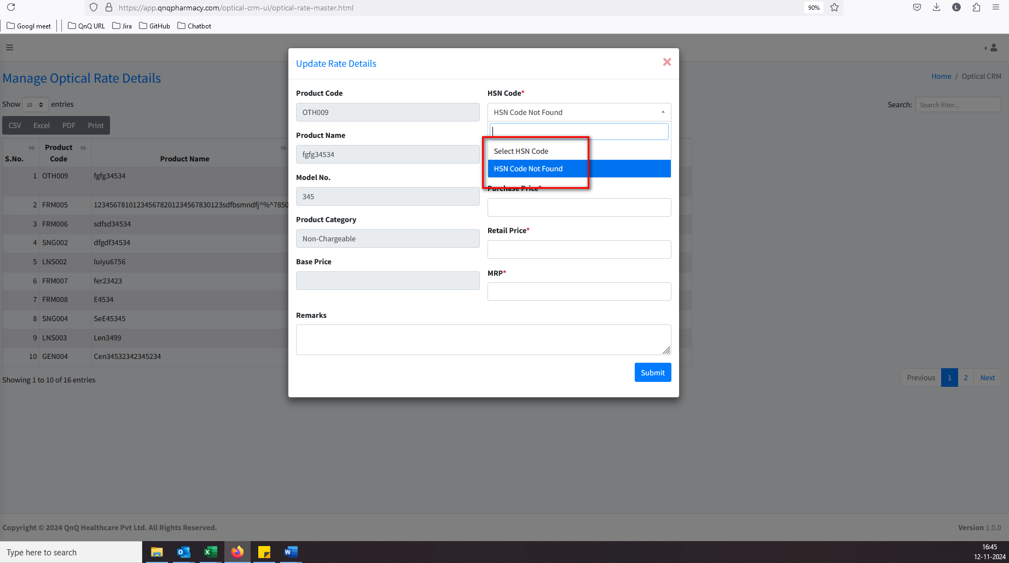//
2. Mismatch Base Price value display 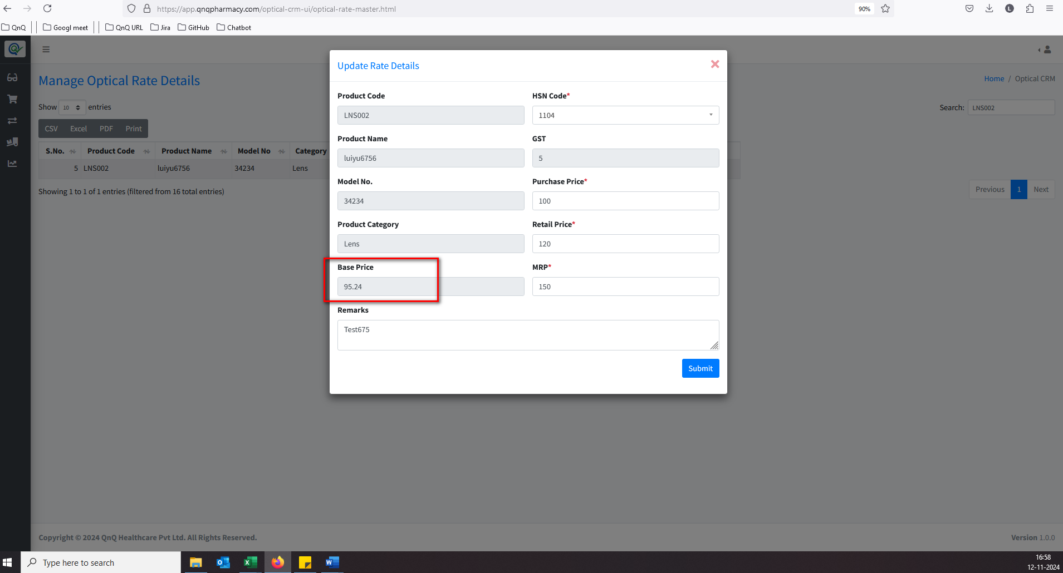//
3. There is improper alignment displayed in the list grid 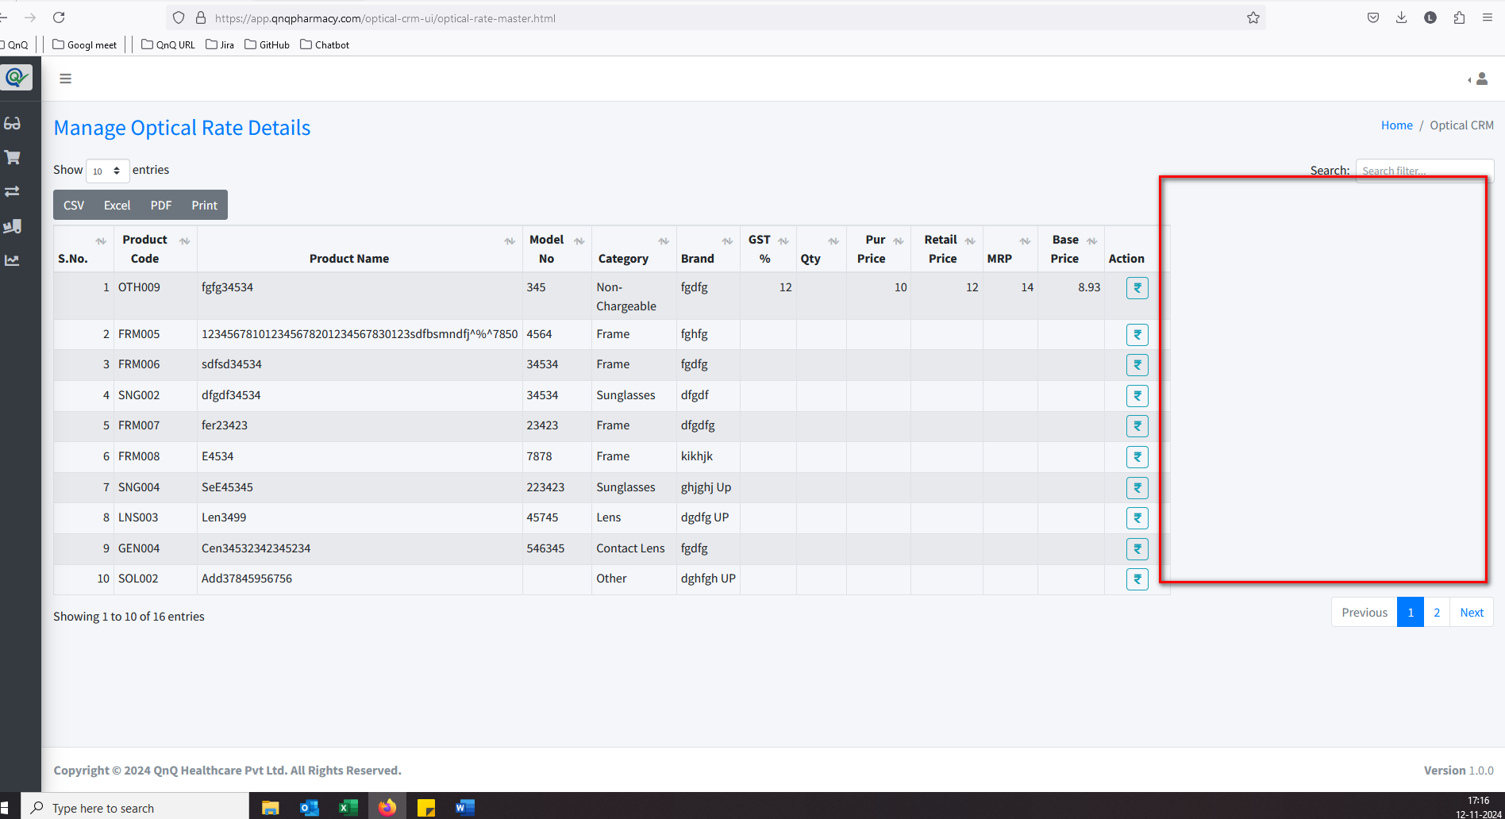//
4. Column Header, Search filter and Pagination not display 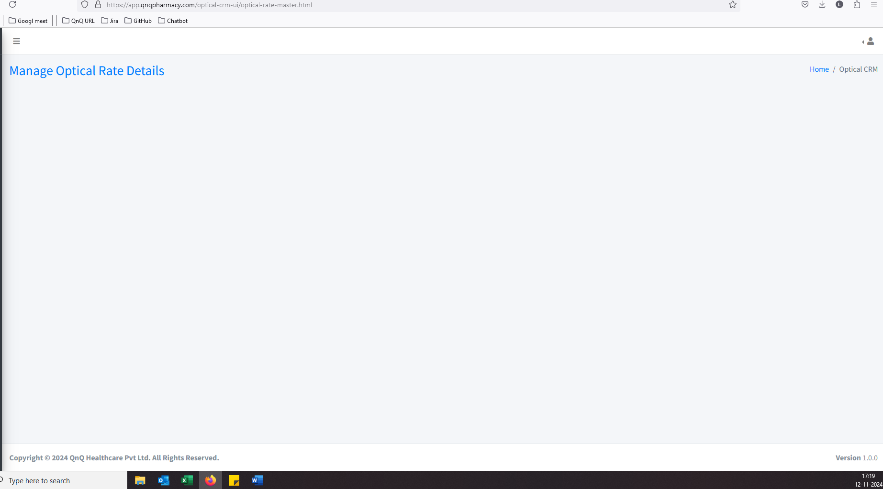//
5. No record available message not display in list grid//
6. Error message display while click the Rate button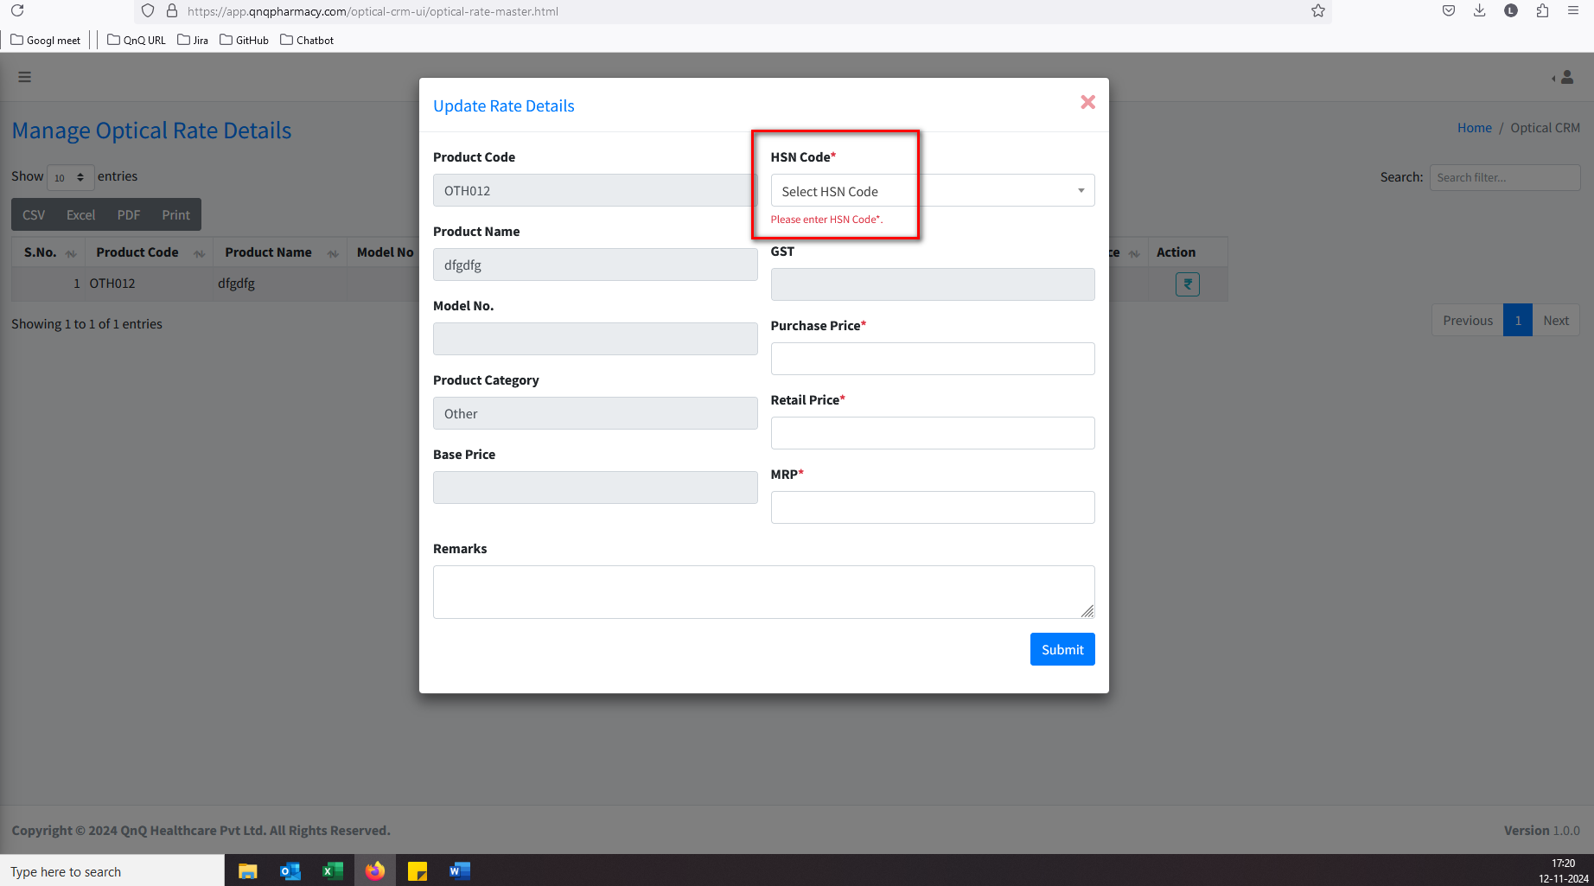//
7. Required error message not display for remarks field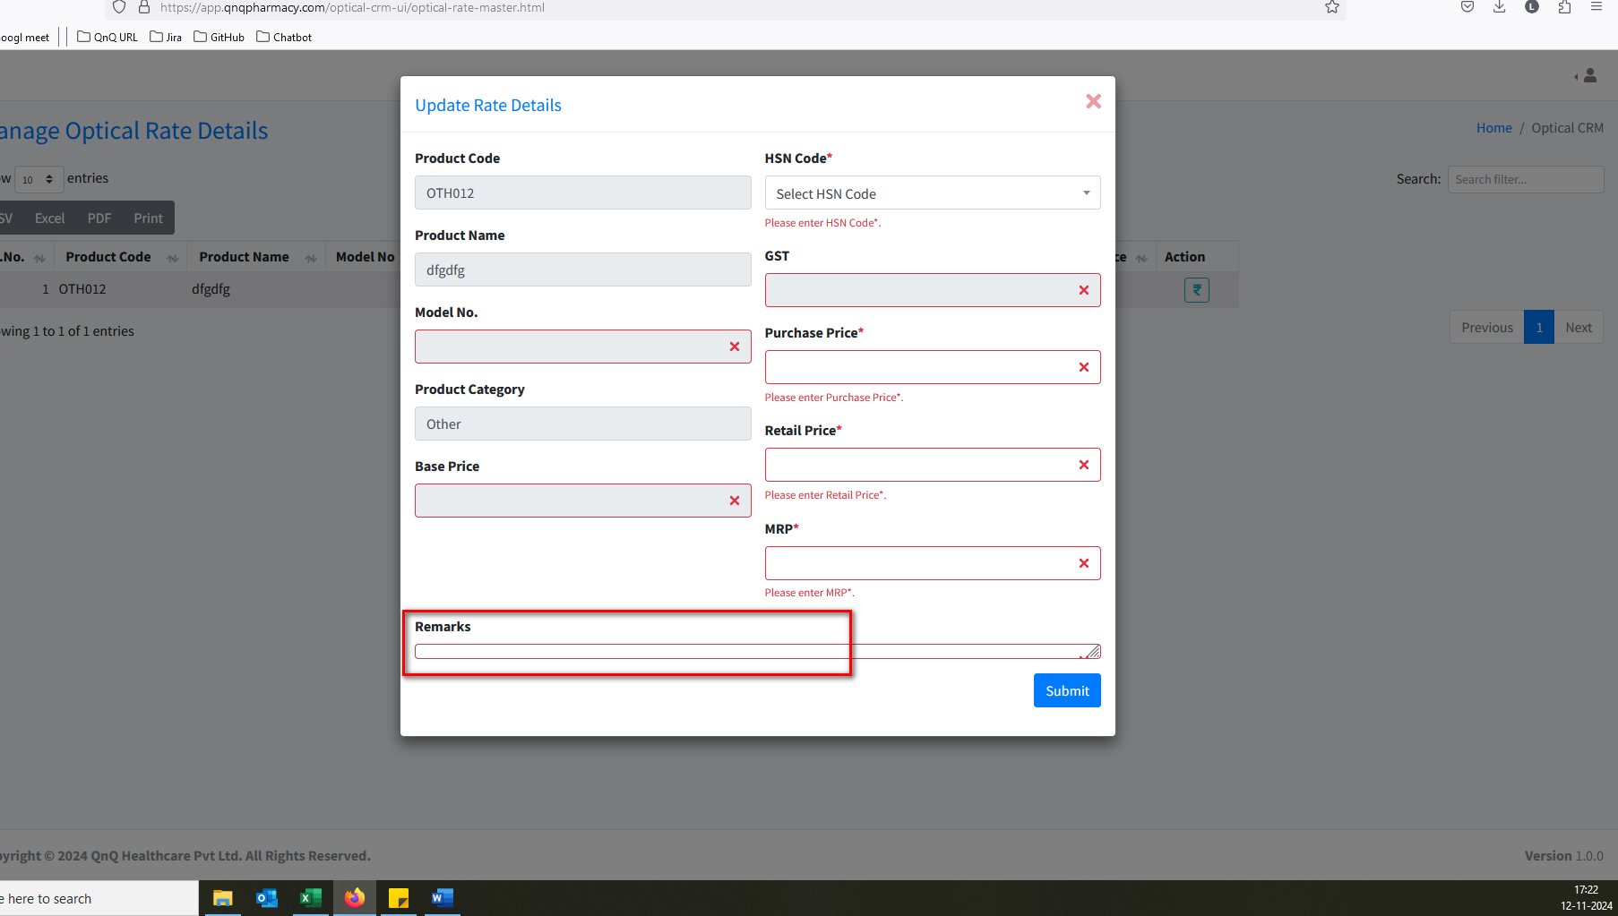//
8. Non-editable field display required highlight colour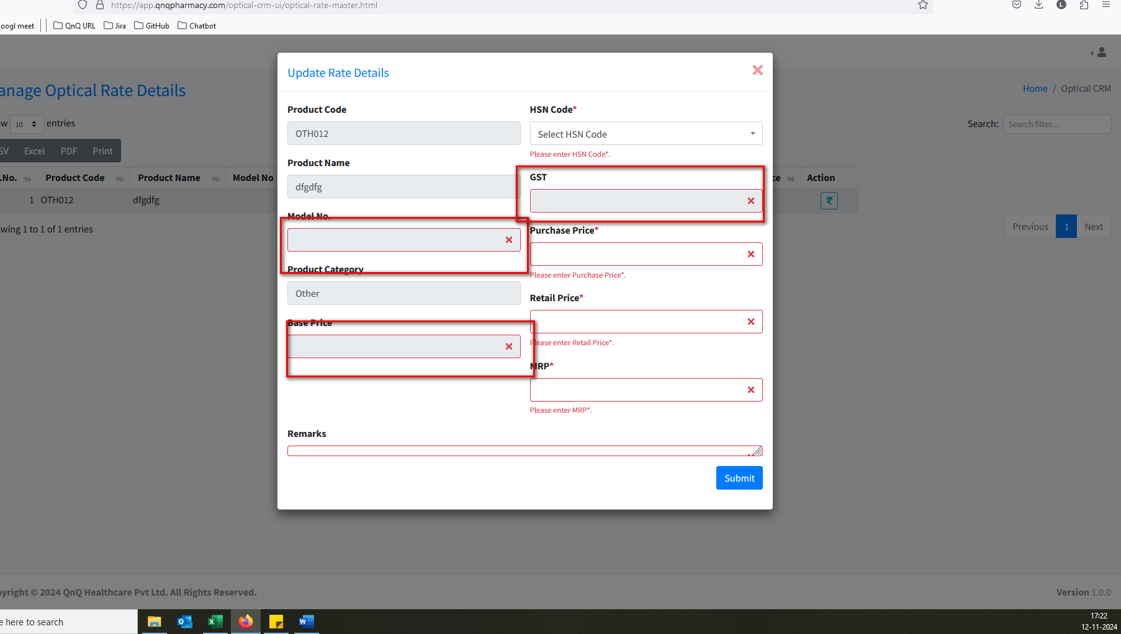//
9. Unable to update rate for Other category record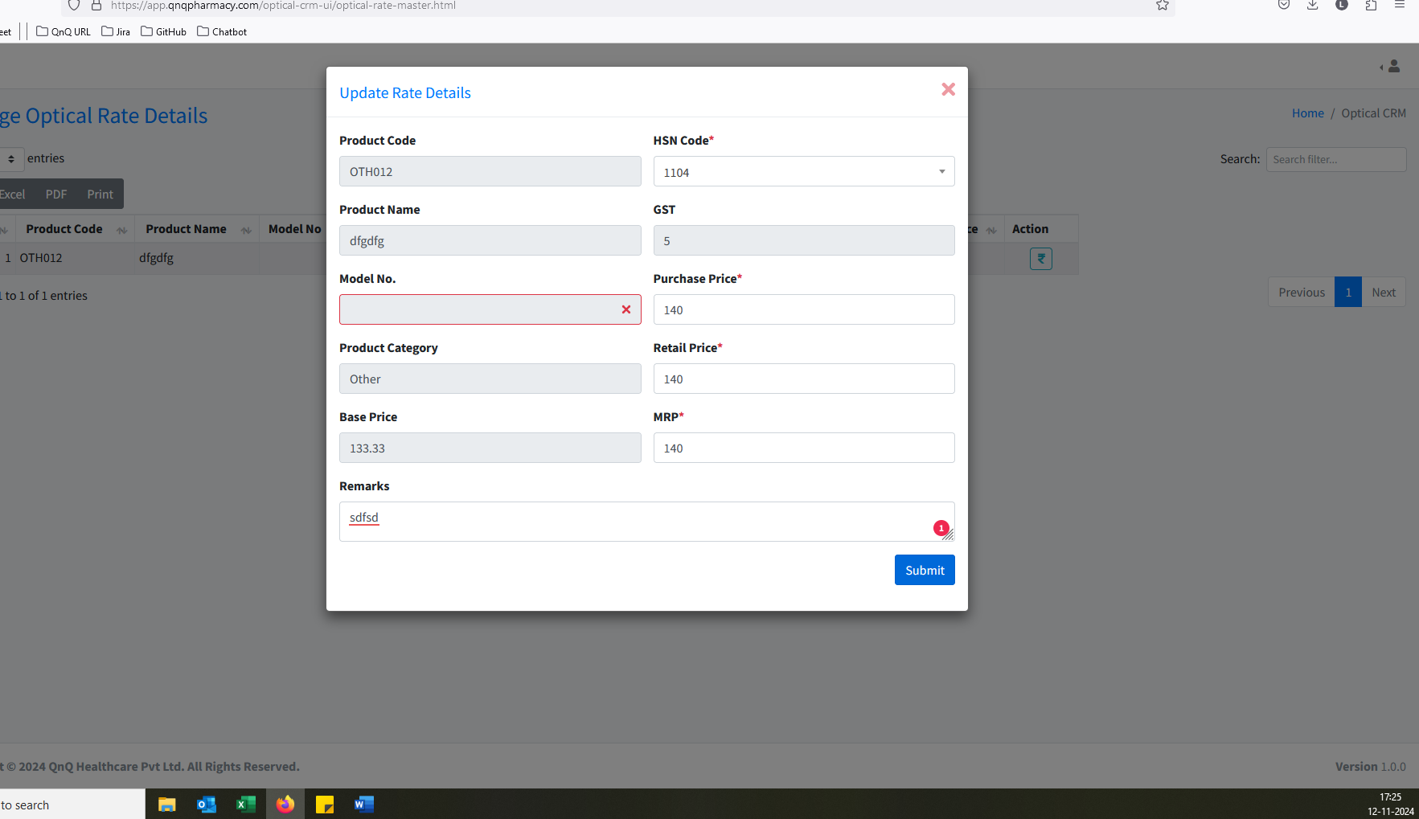//
10. Unwanted tool tip display in HSN Code field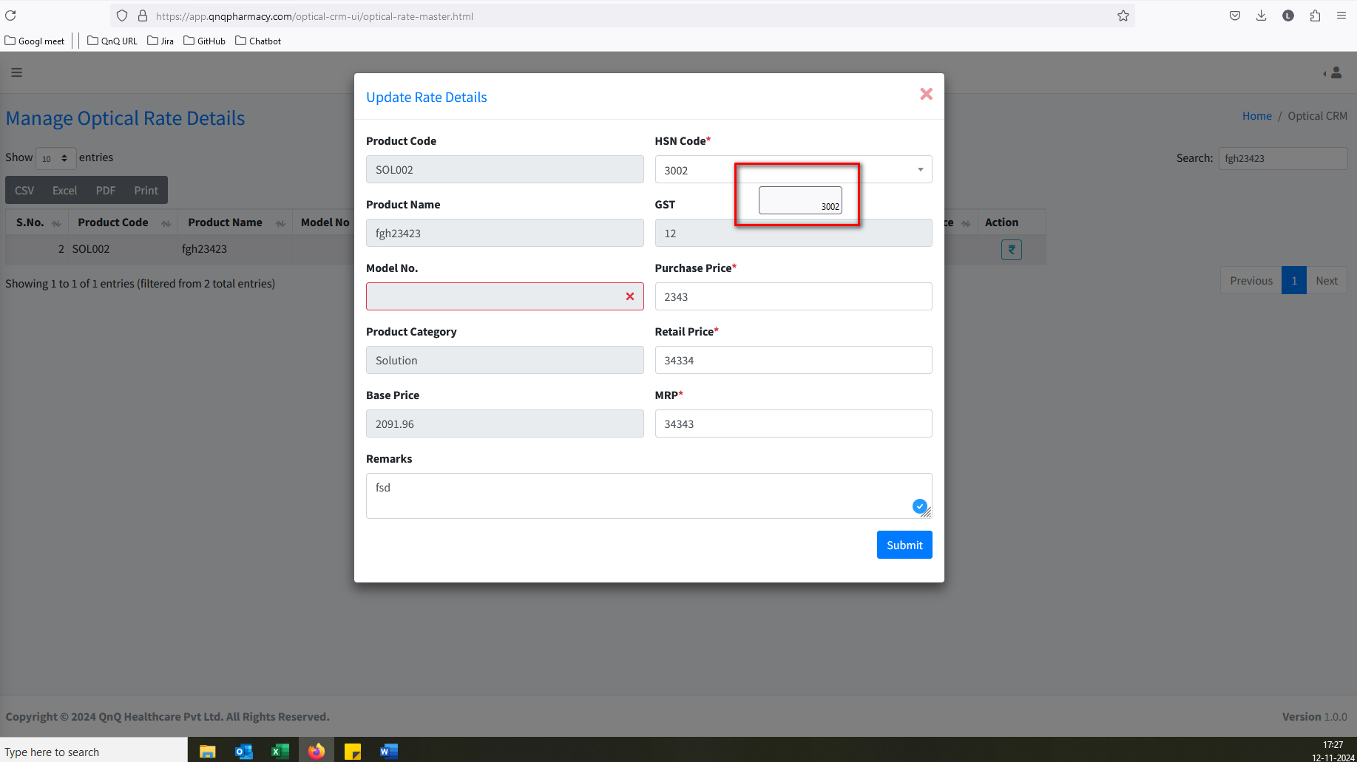//
11. Unwanted content display in Rate icon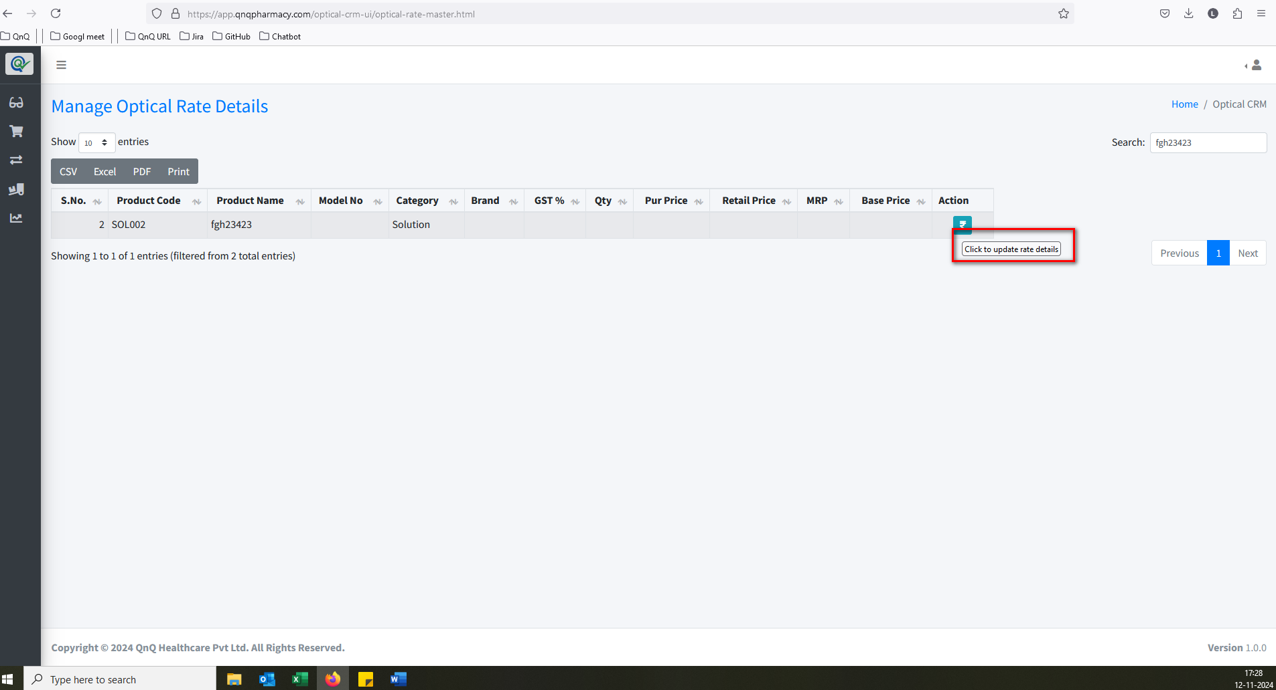//
12. An unwanted page is being opened when clicking the Home button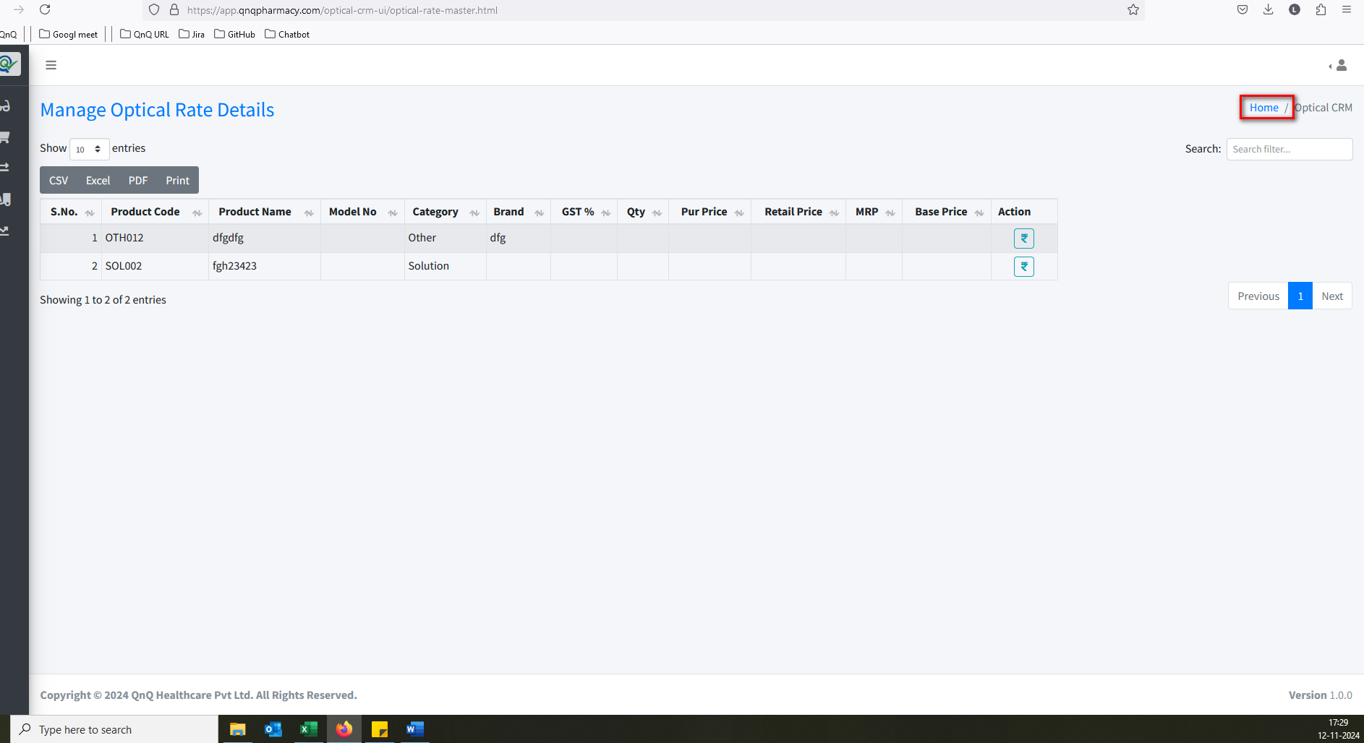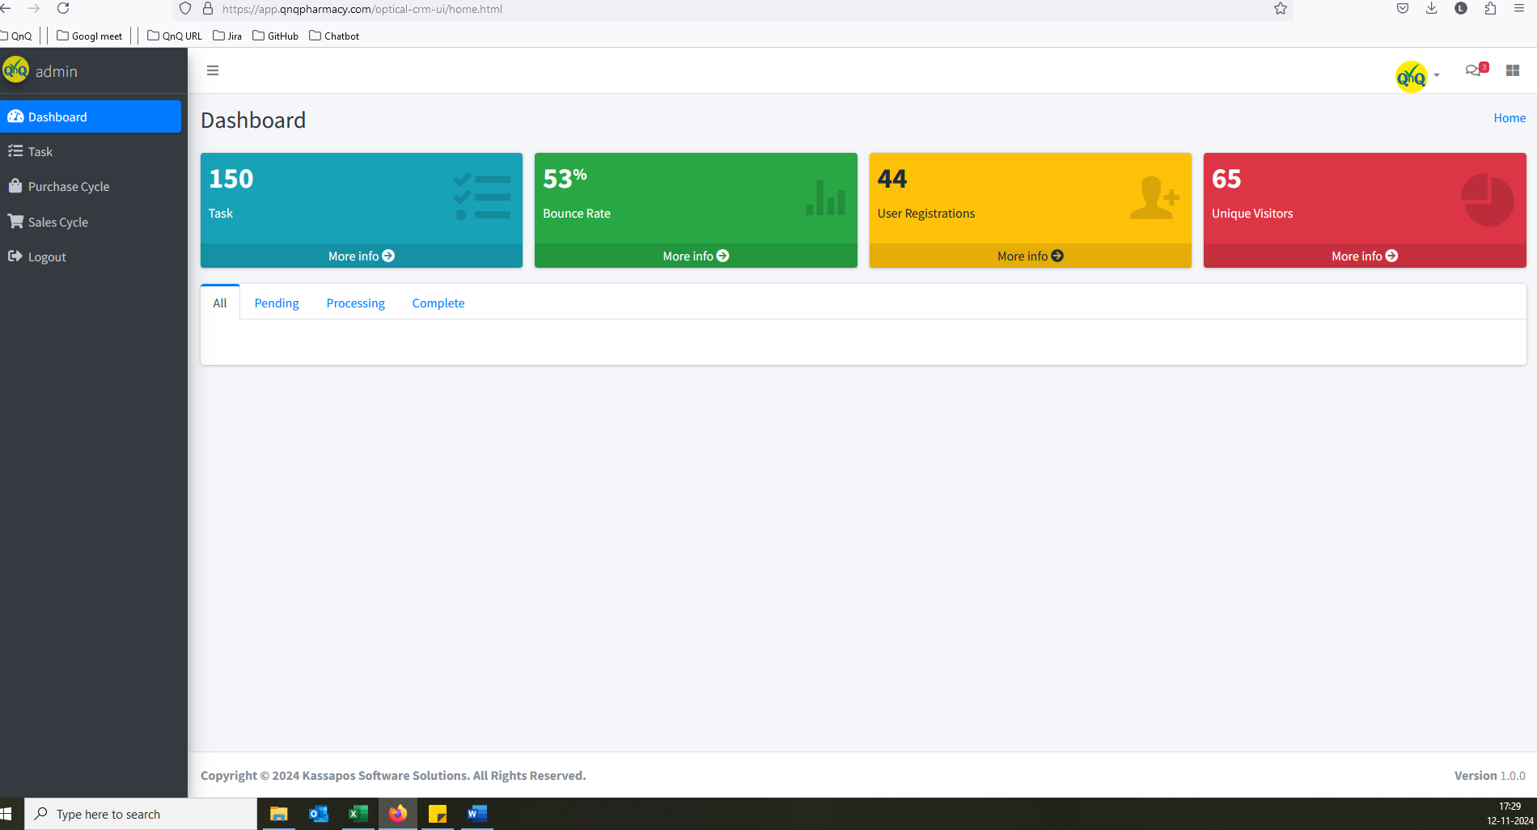//
13. Unwanted column display in list grid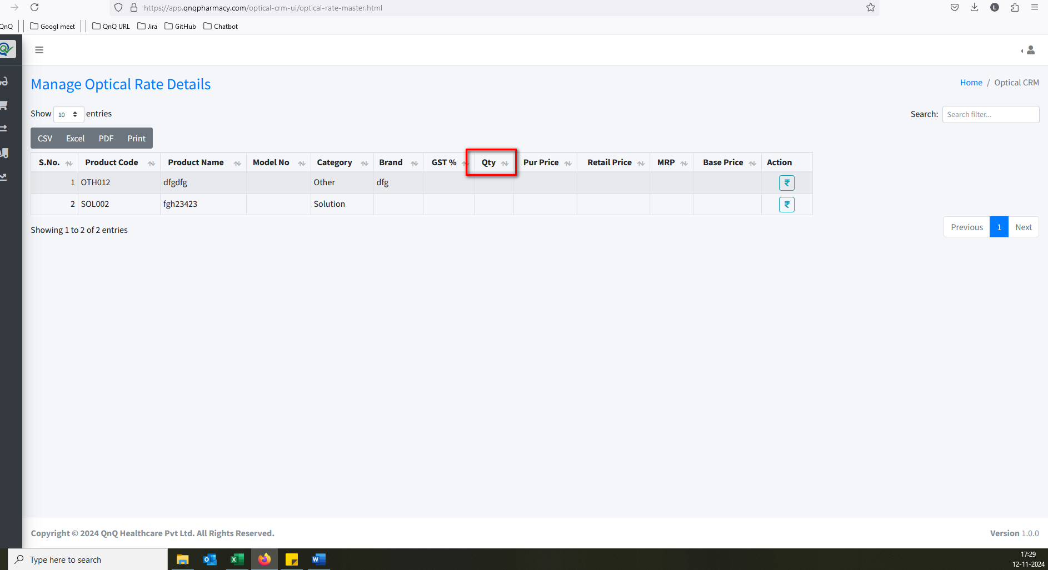//
14. Unable to update rate for Solution category record 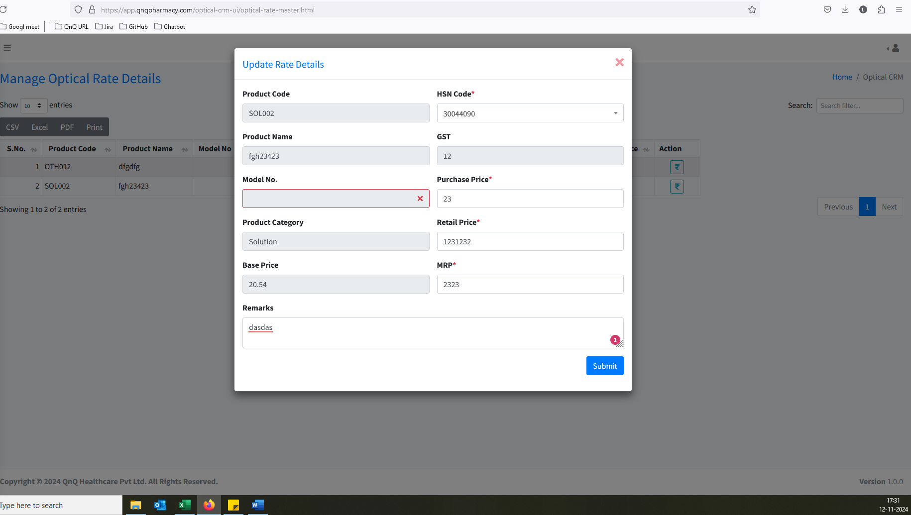 //
15. Required Error message display while click rate button 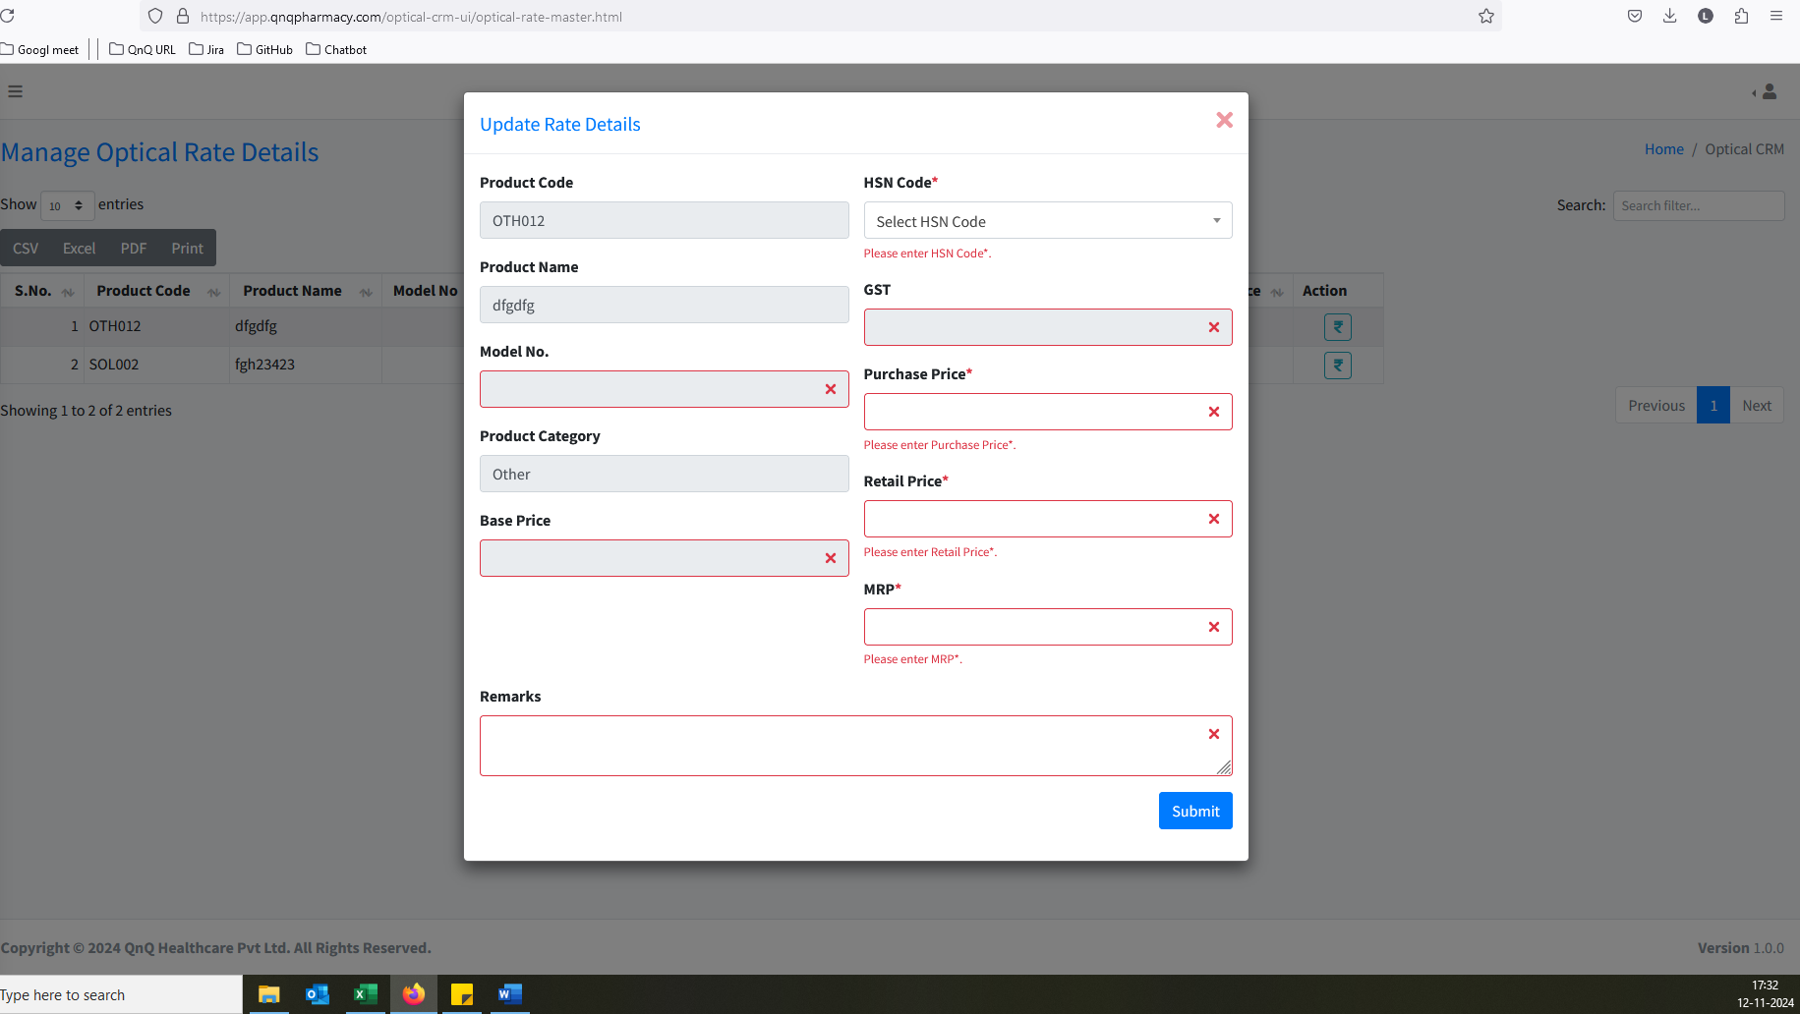 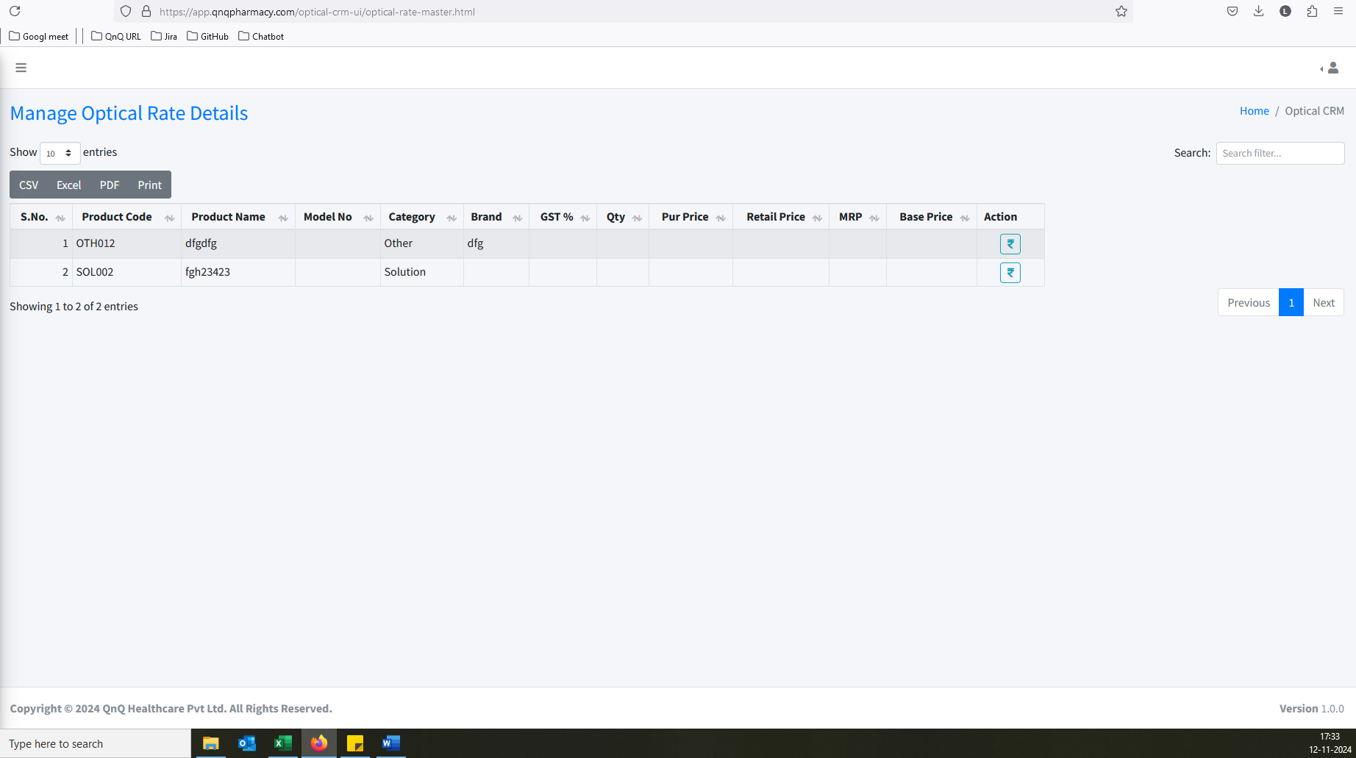 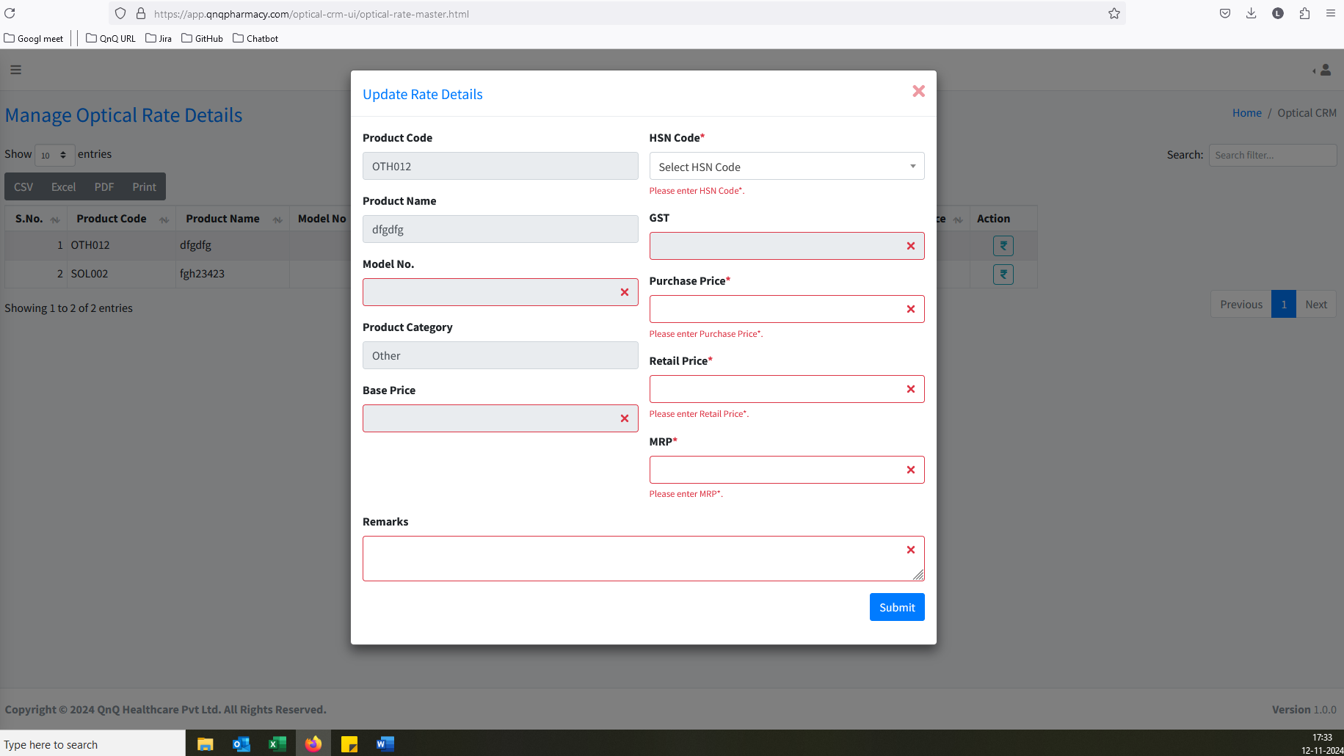 //
16. Placeholder/Inner Text not display in all field 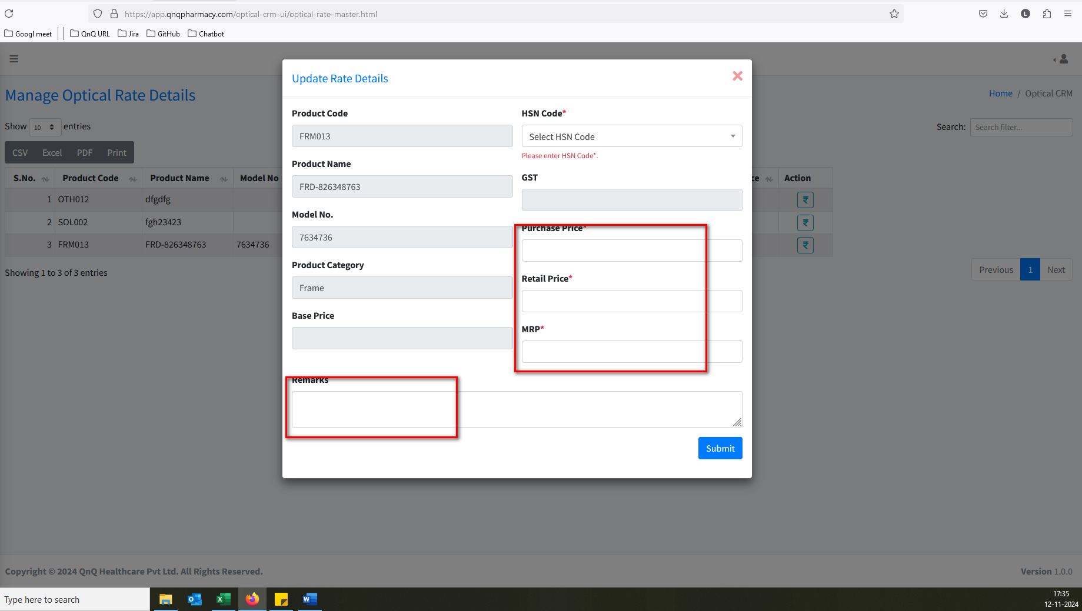 //
17. Success message display mismatch content 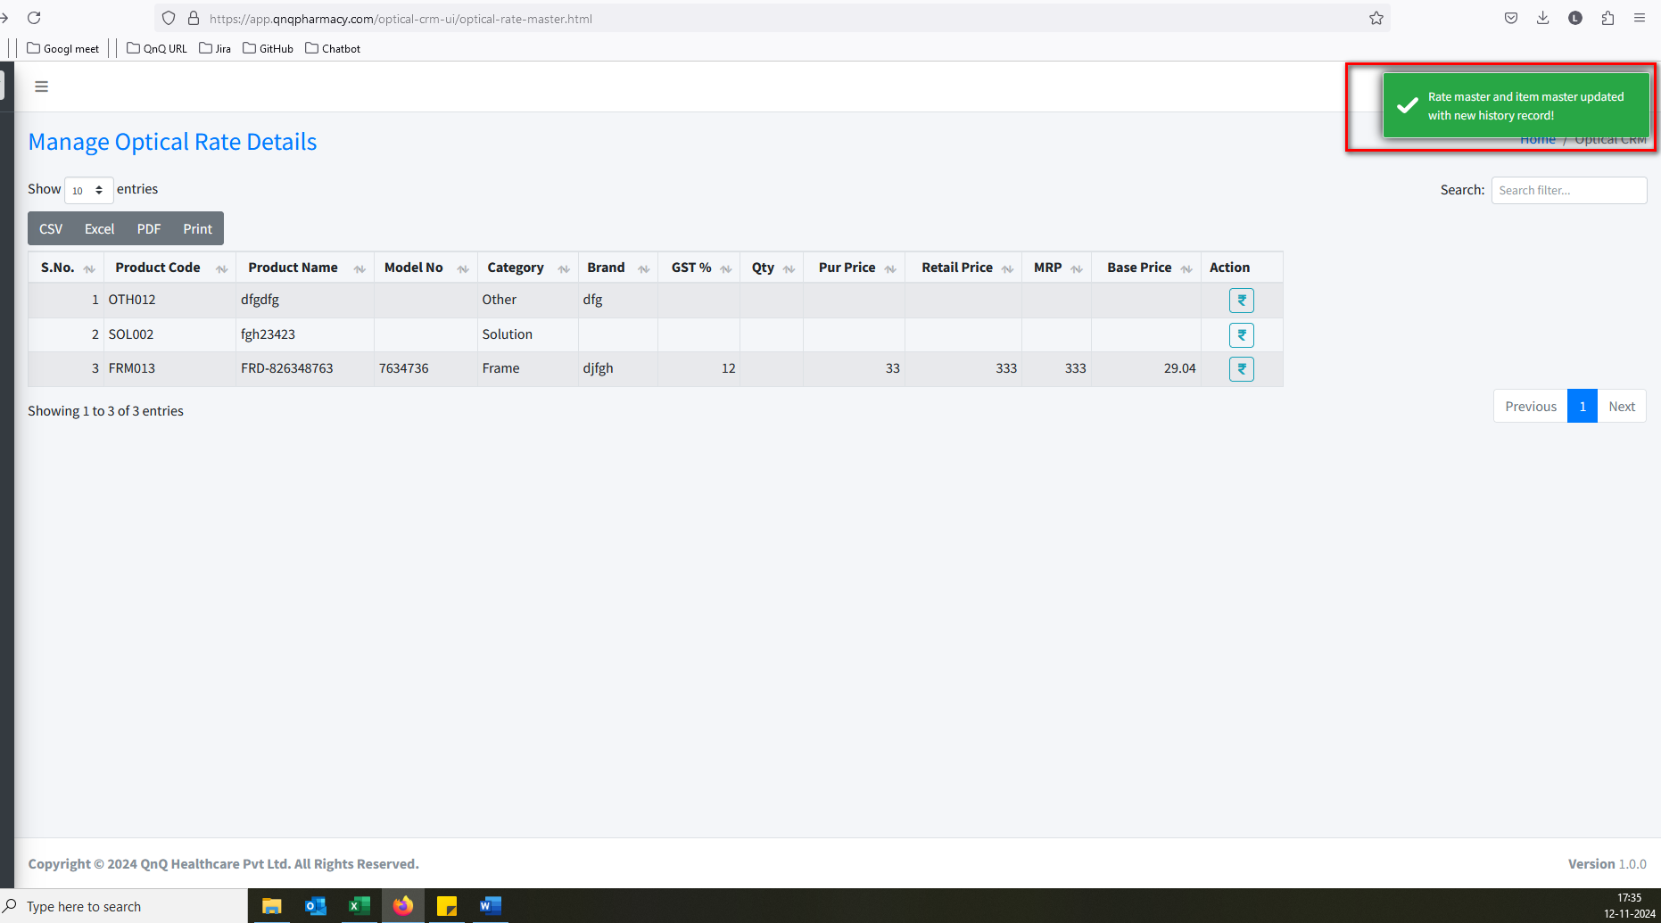 //
18. Update message display mismatch content 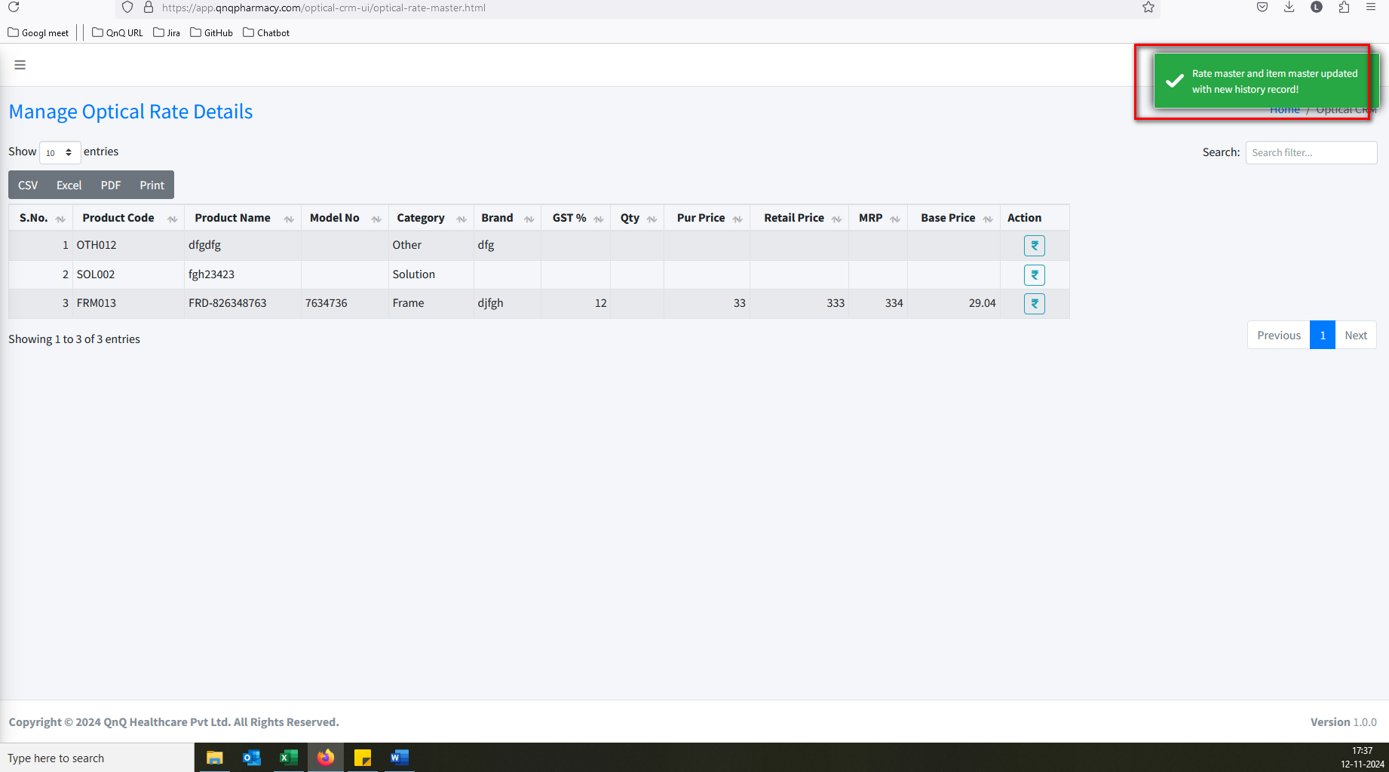 //
19. Updated success message display without updates any value 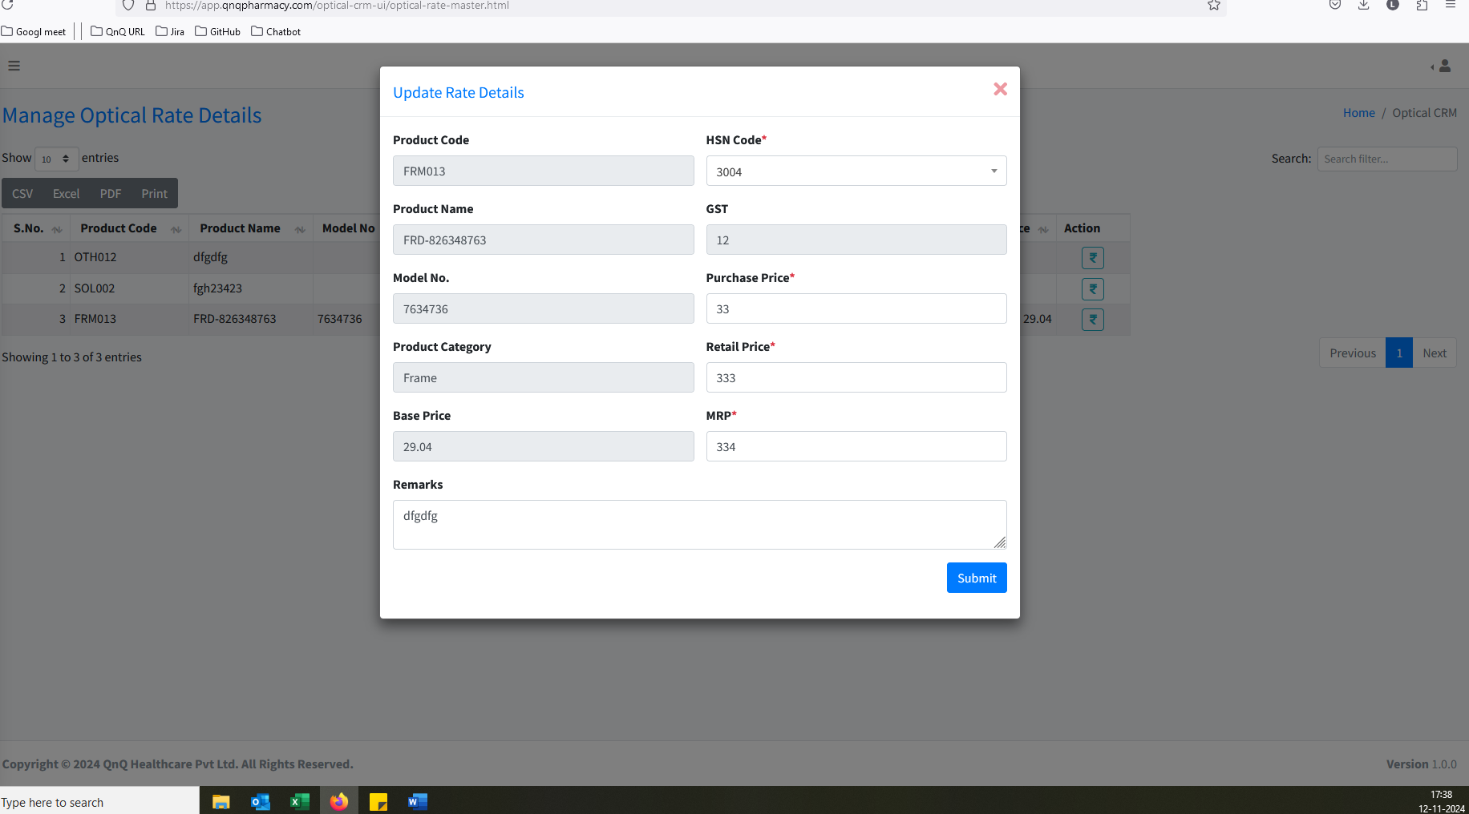 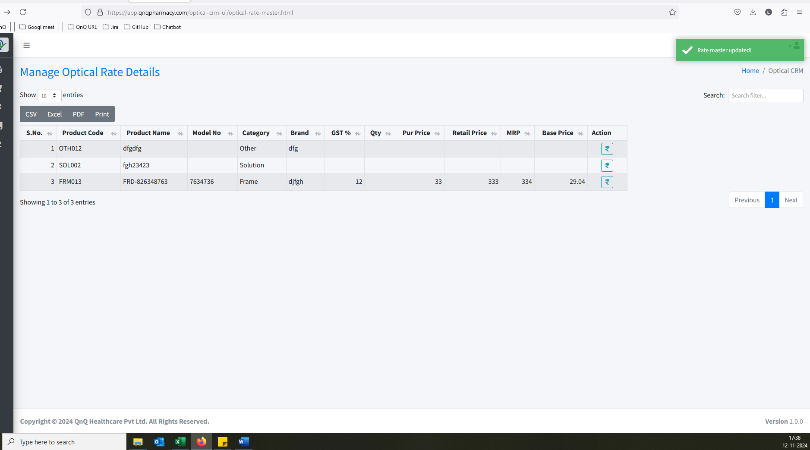 //
20. Unwanted Clear icon display in all fields 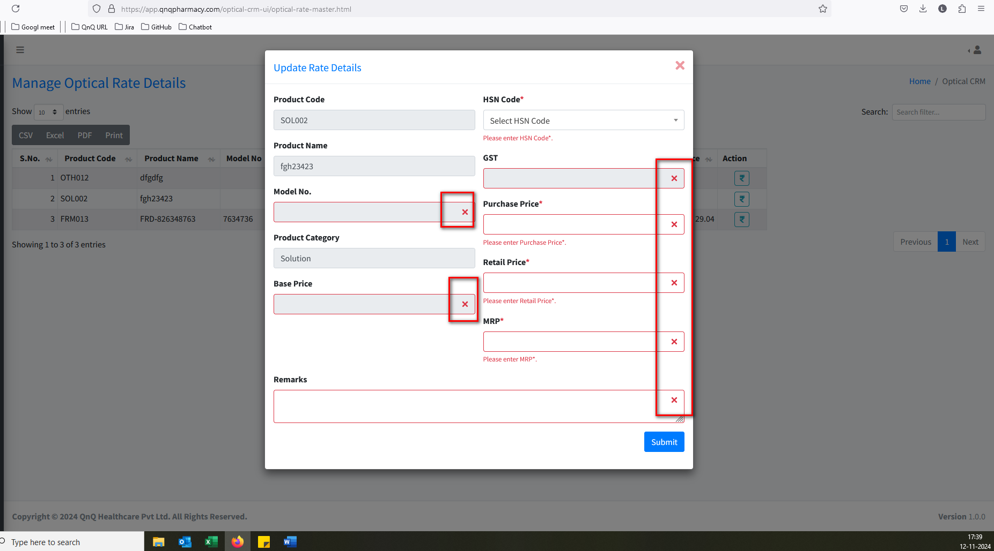 //
21. Unwanted content display in Base price field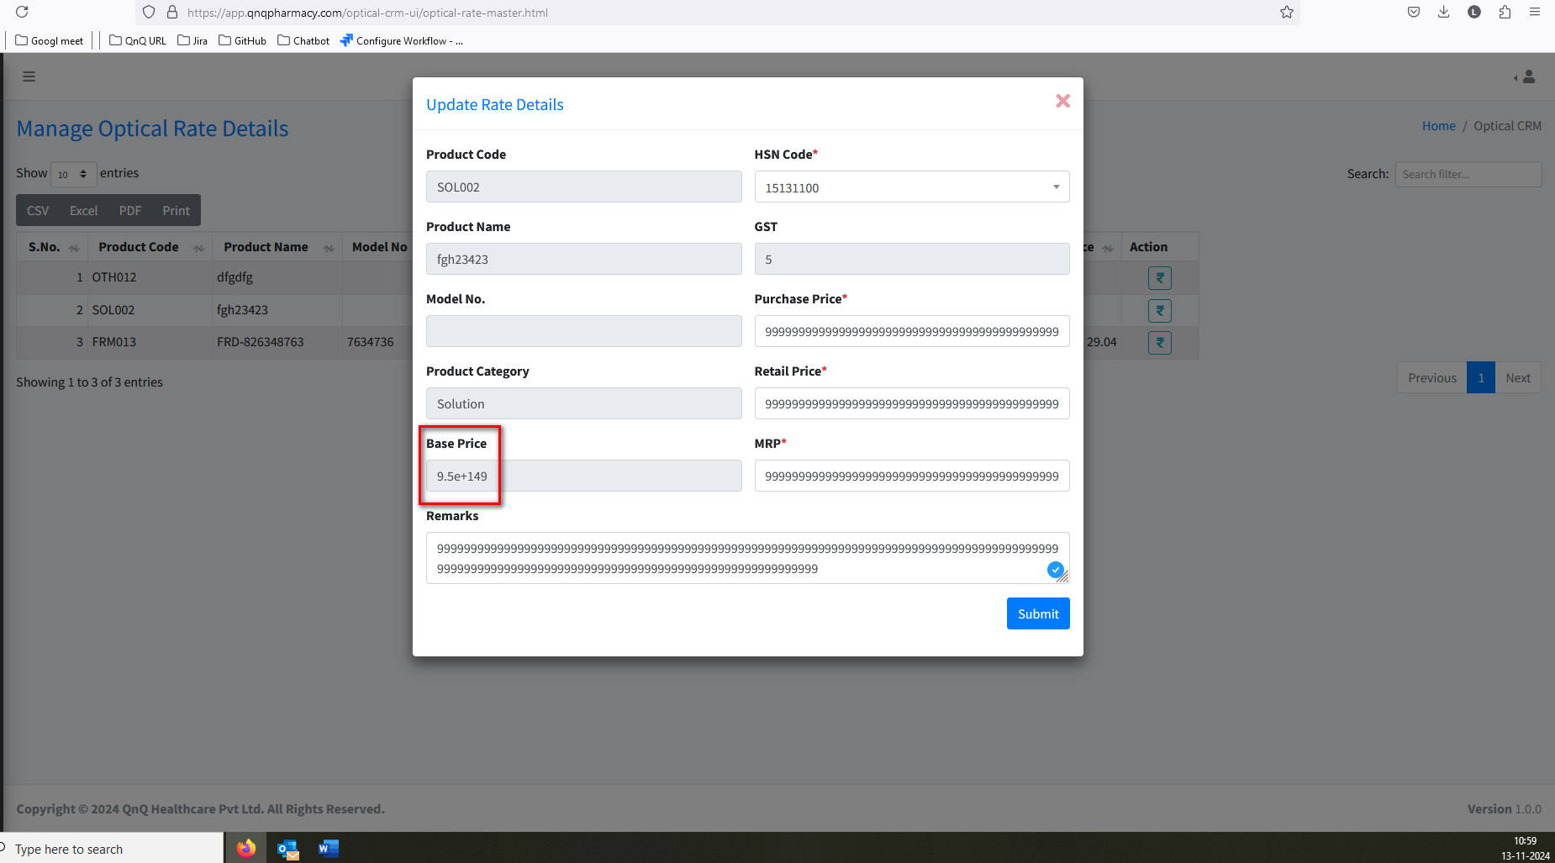//
22. Rate fields allow more than 100 value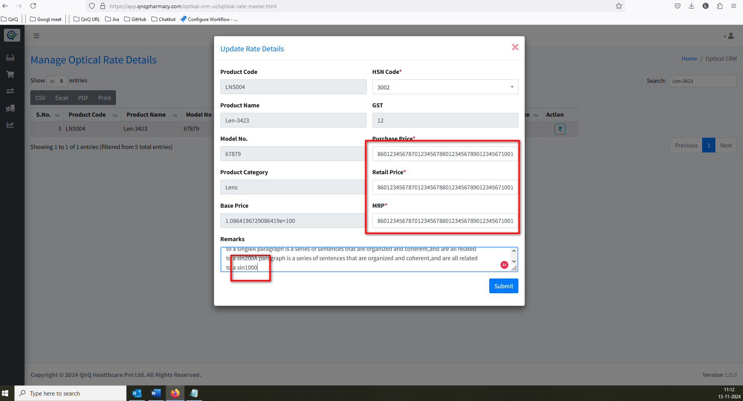//
23. Unwanted error message while click submit button with max value 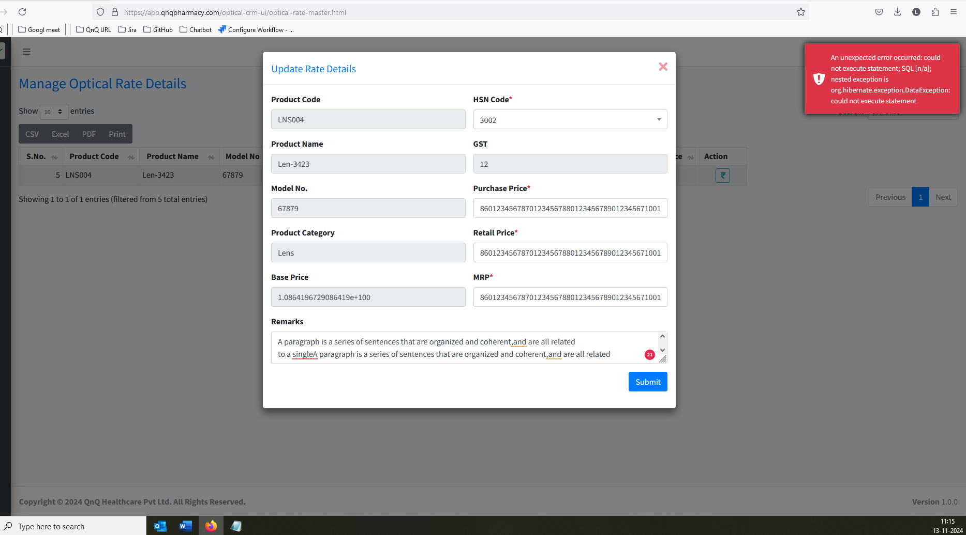//
24. Mismatch column header name display in list grid 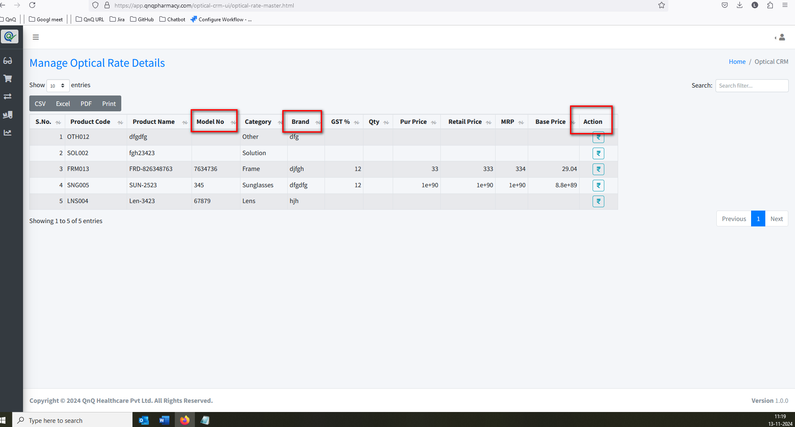//
25. Display error messages with lowercase initial letters 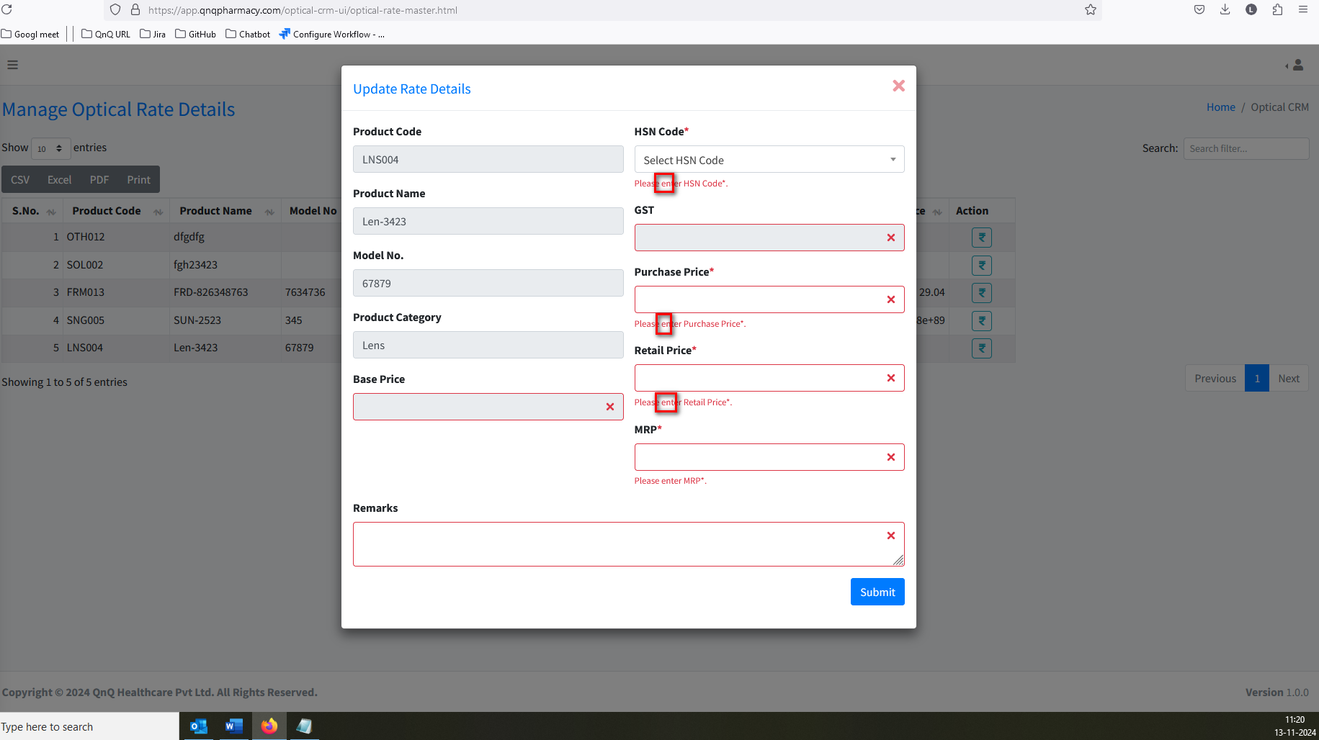//
26. Base Price value not getting clear/update while update the Purchase Price value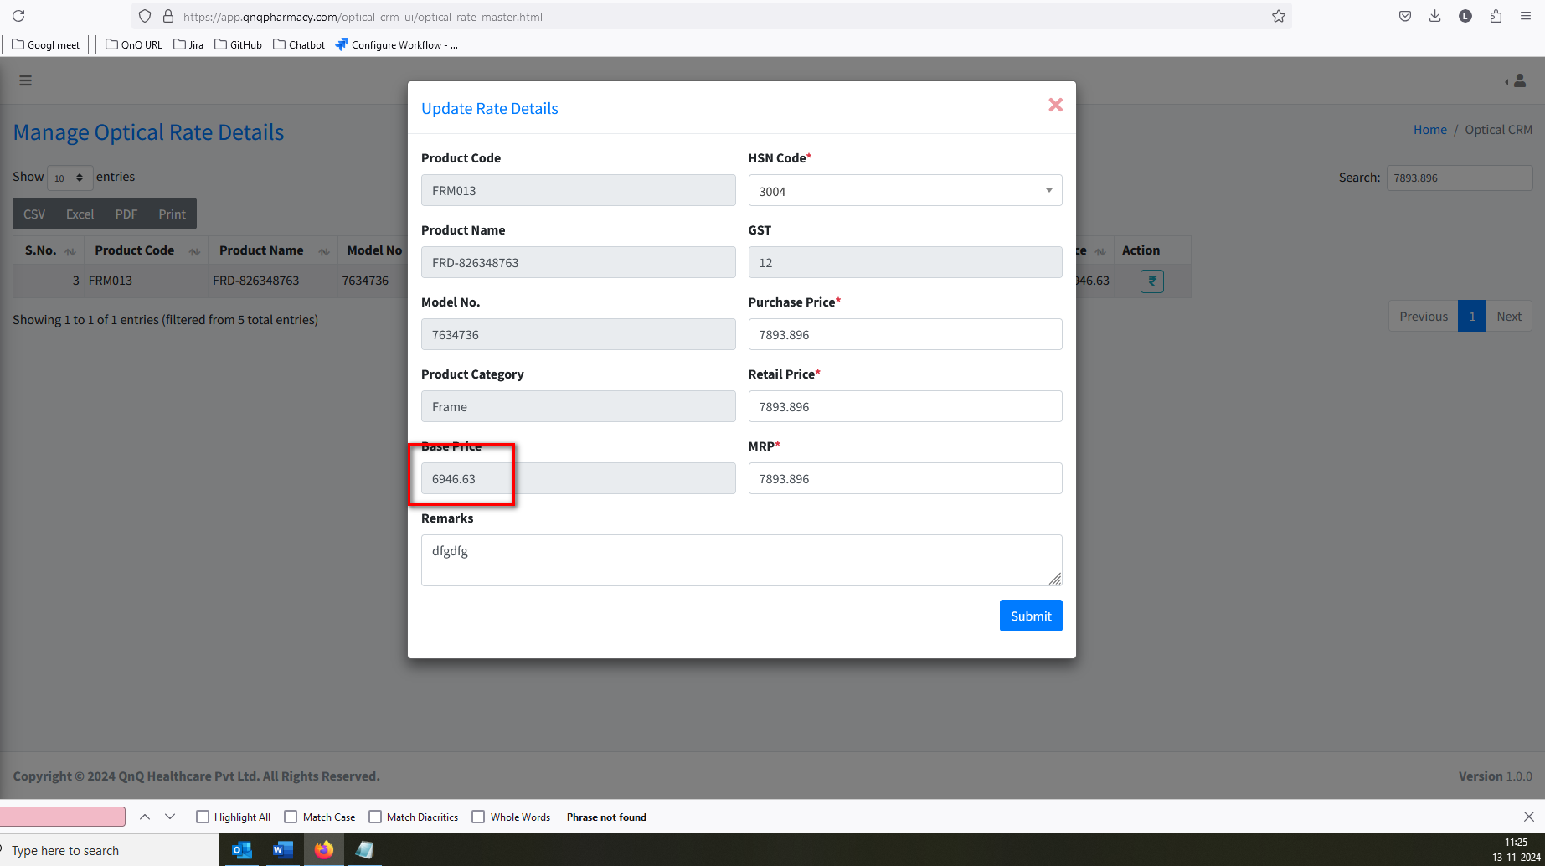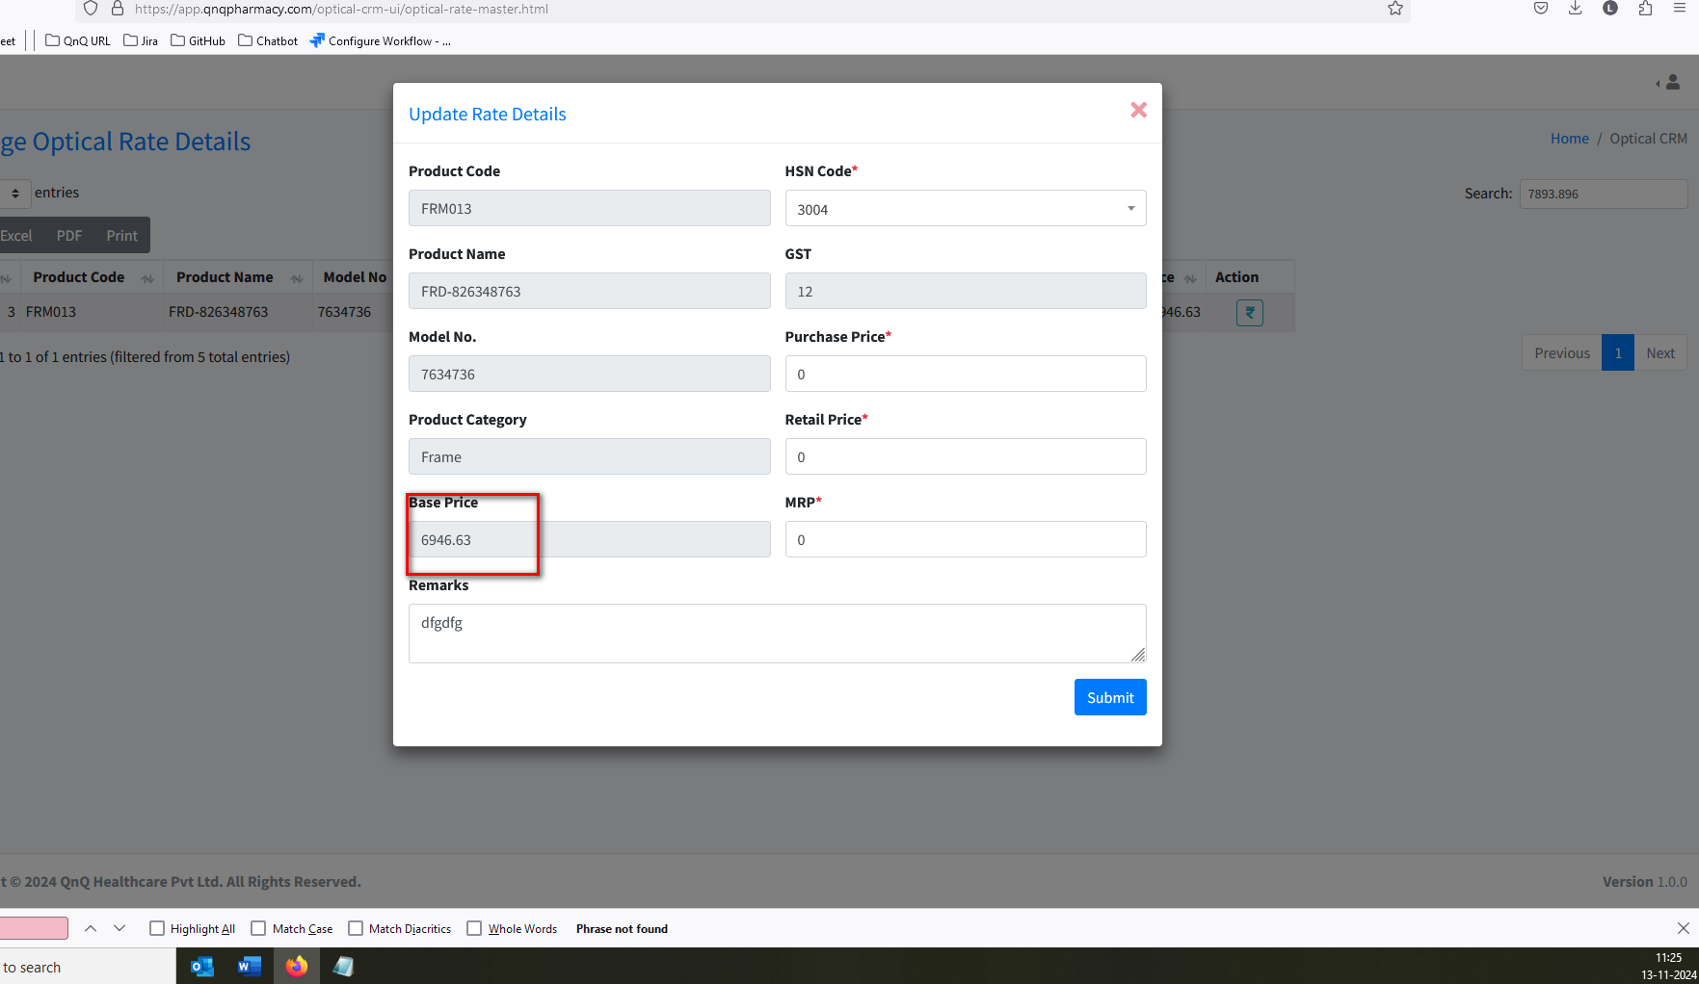//
27. Mismatch error message display while clear the MRP/Retail Price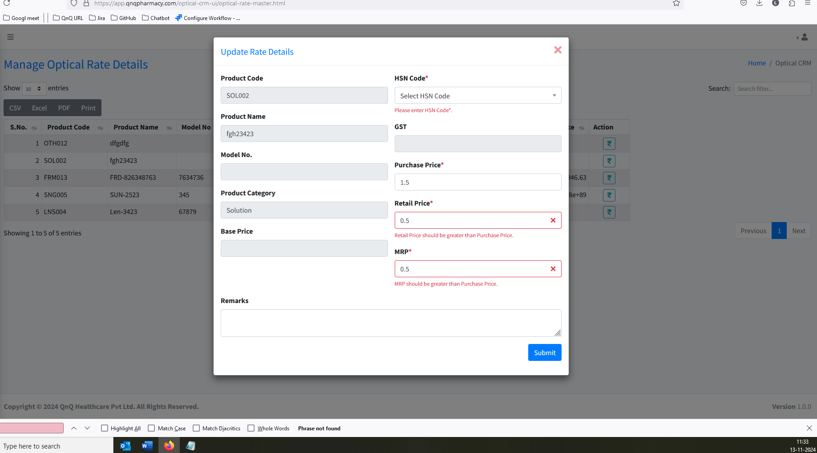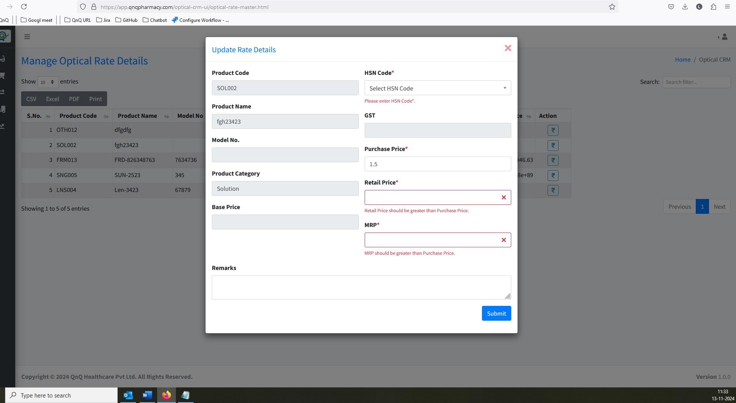//
28. Given value not converted as decimal value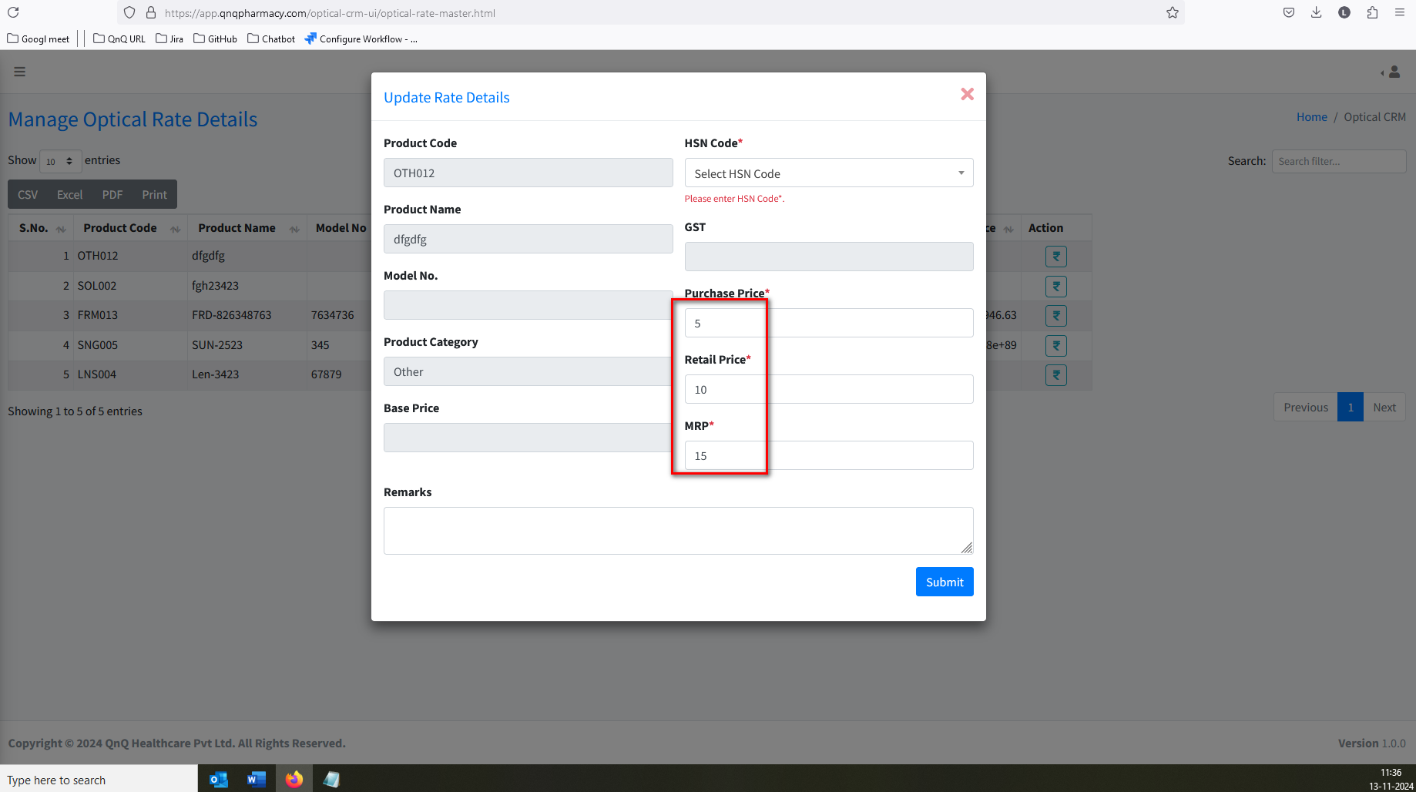 //
29. Error message not display while greater than Purchase price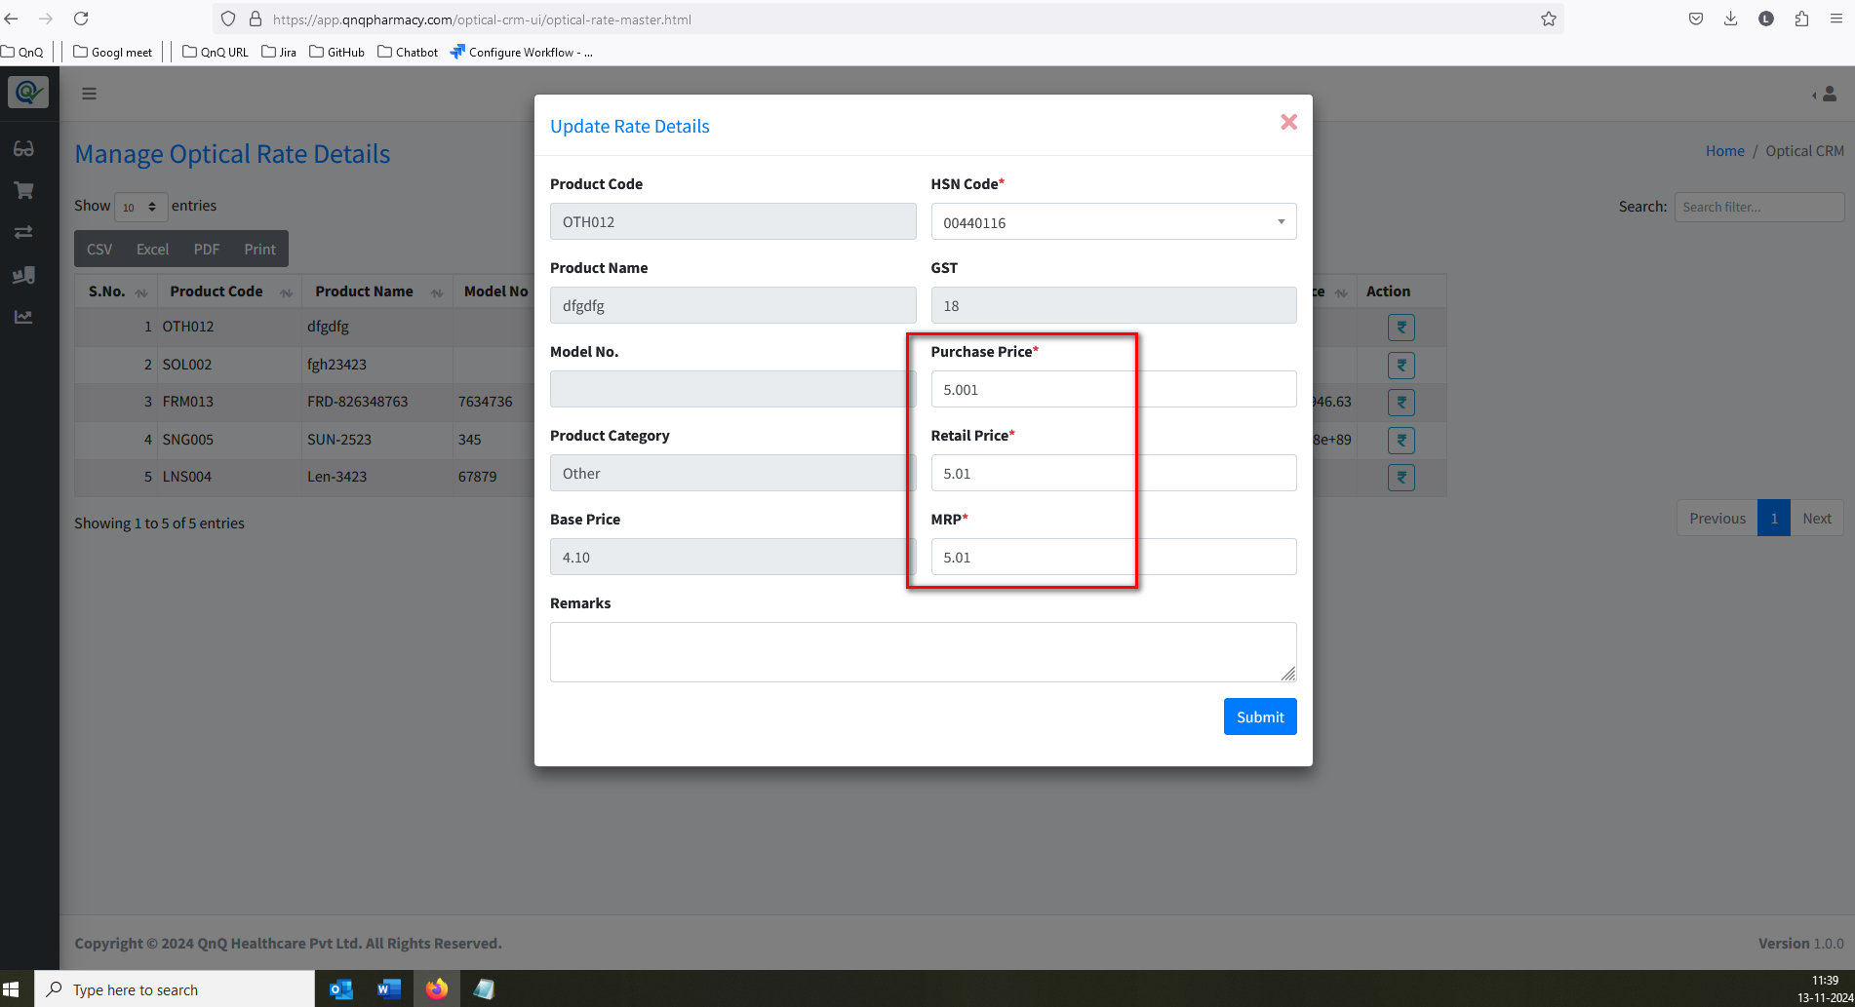//
30. Confirmation message not display while close the pop up with updated value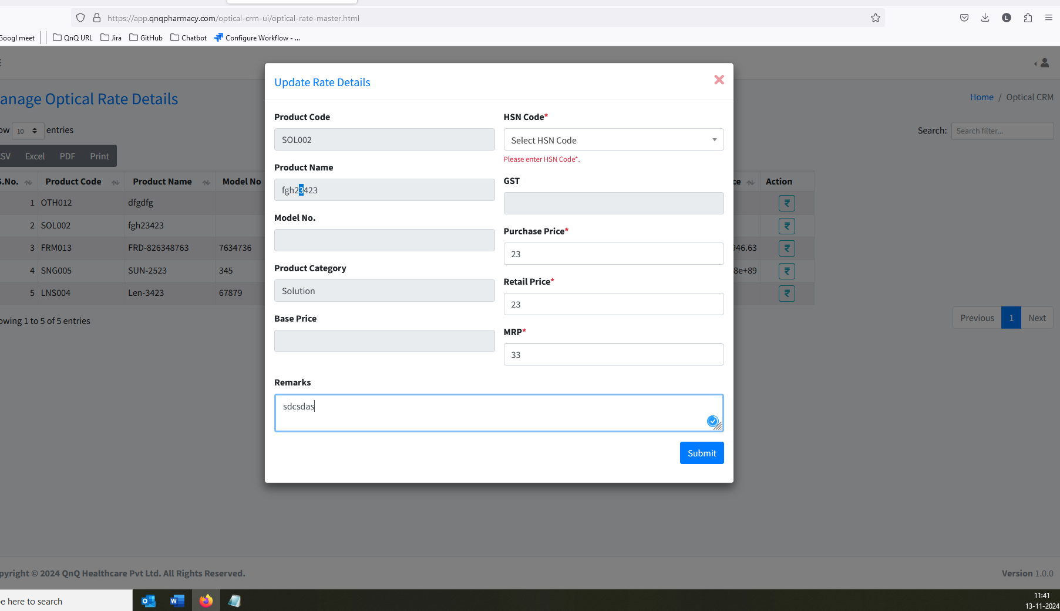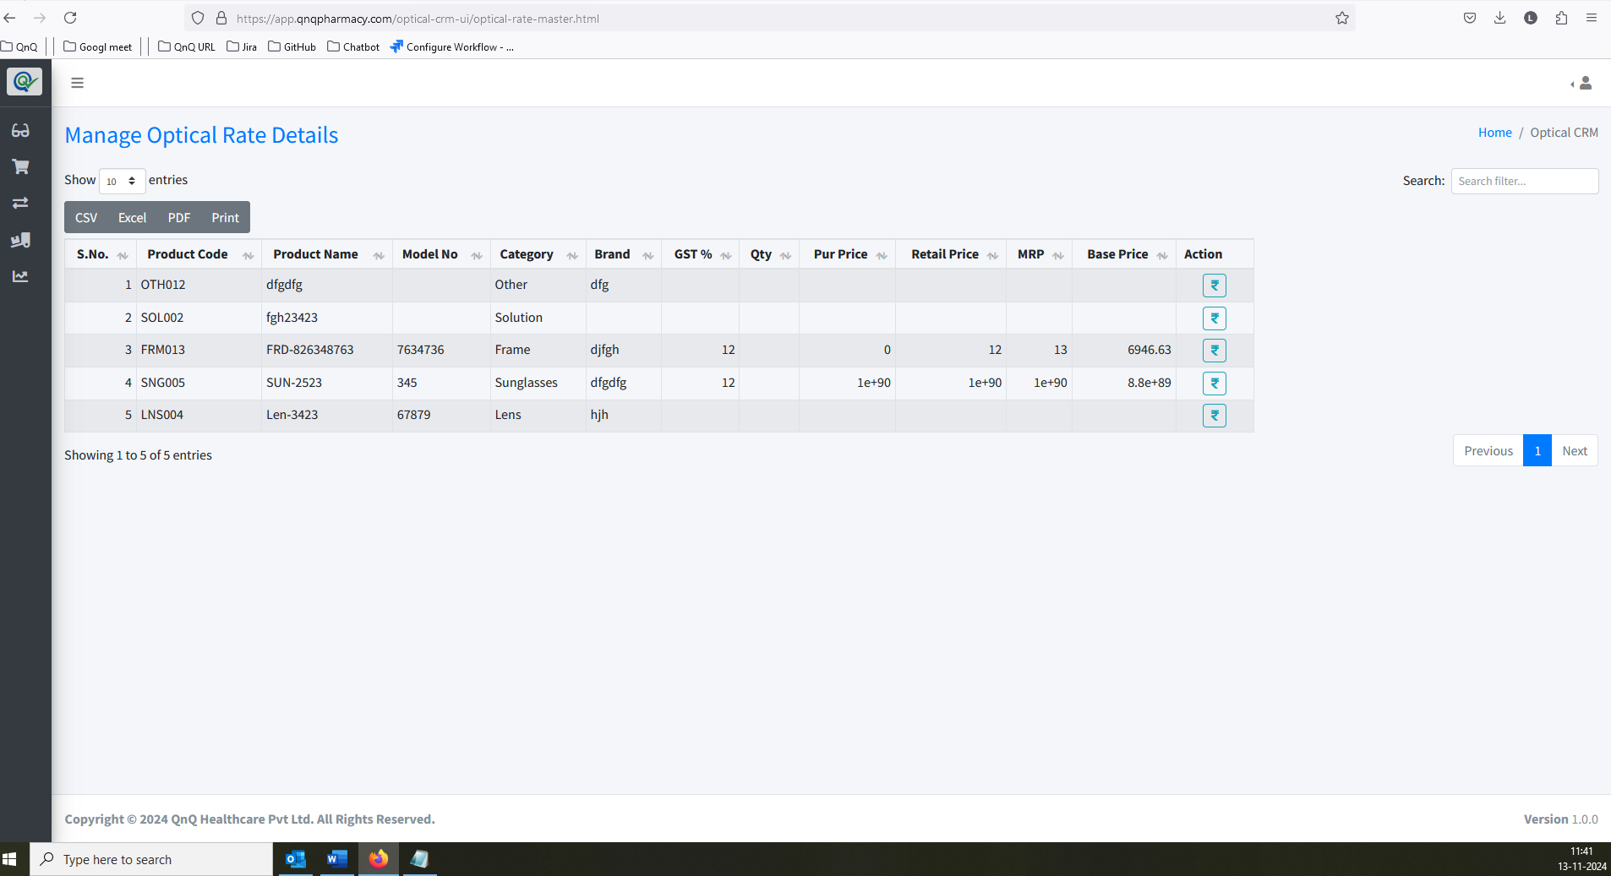//
31. Page not displays within the outer line/Card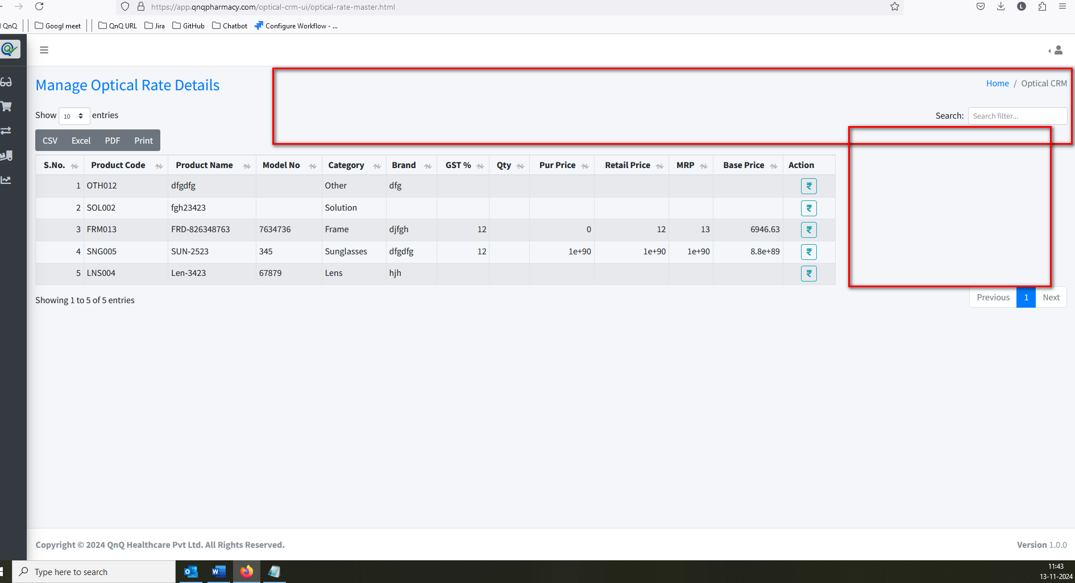//
32. The error message is not displaying the correct content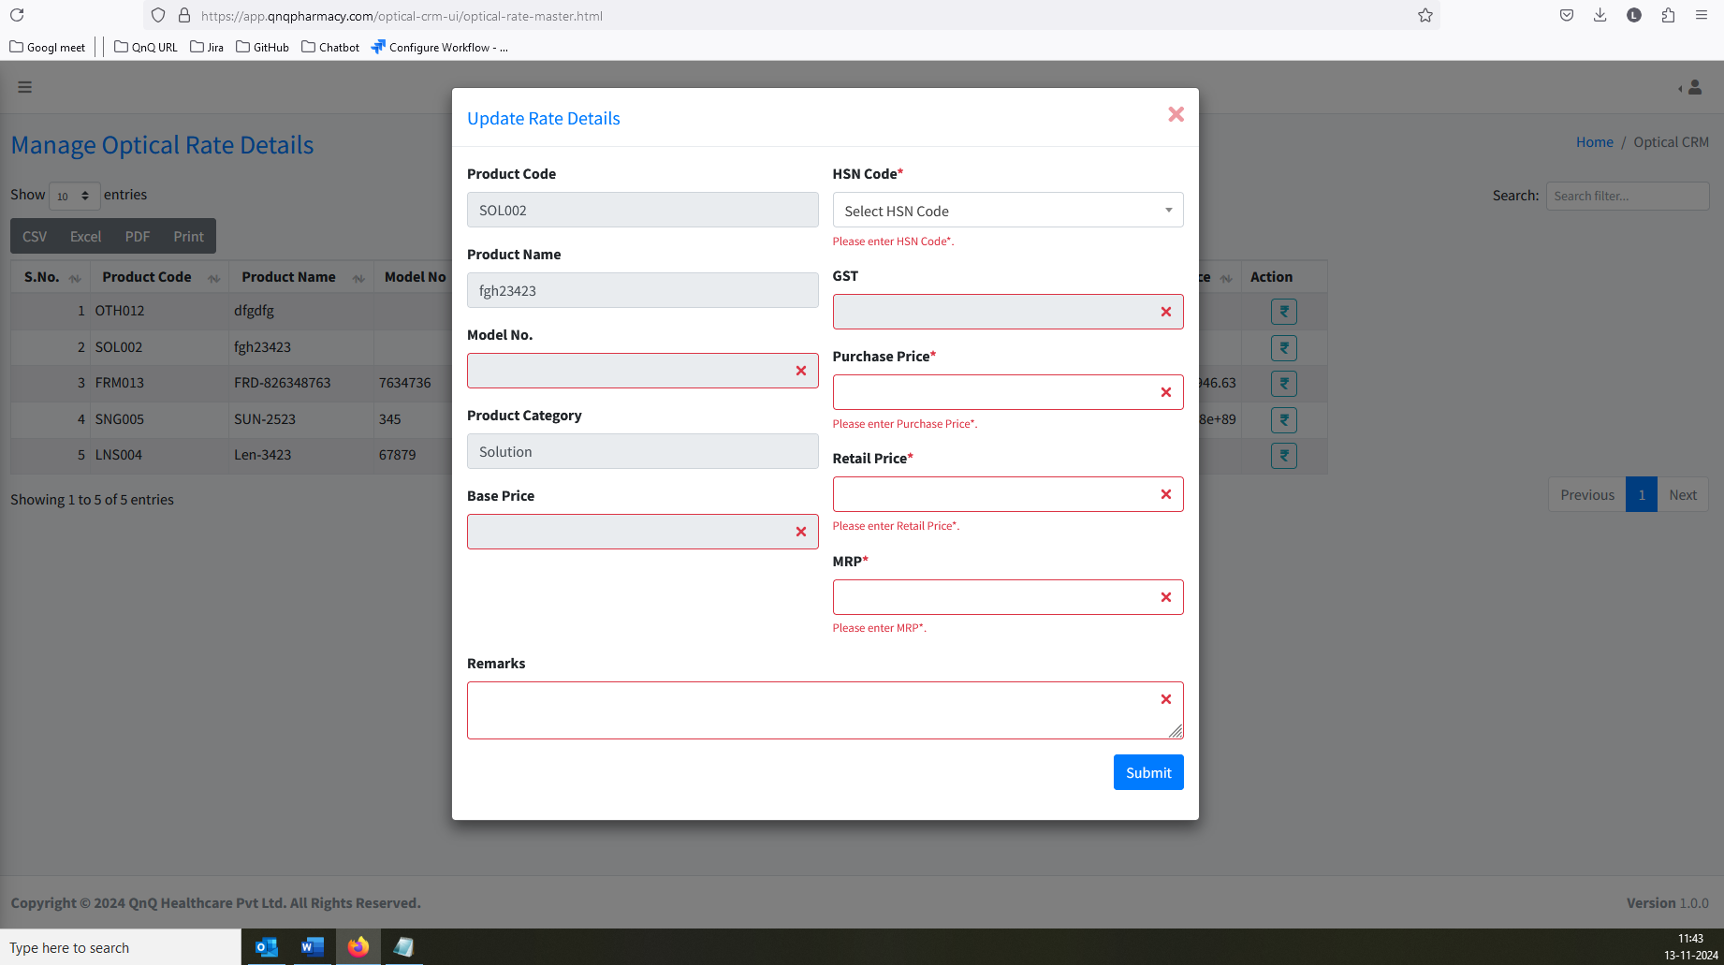//
33. Recently updated record not display as first record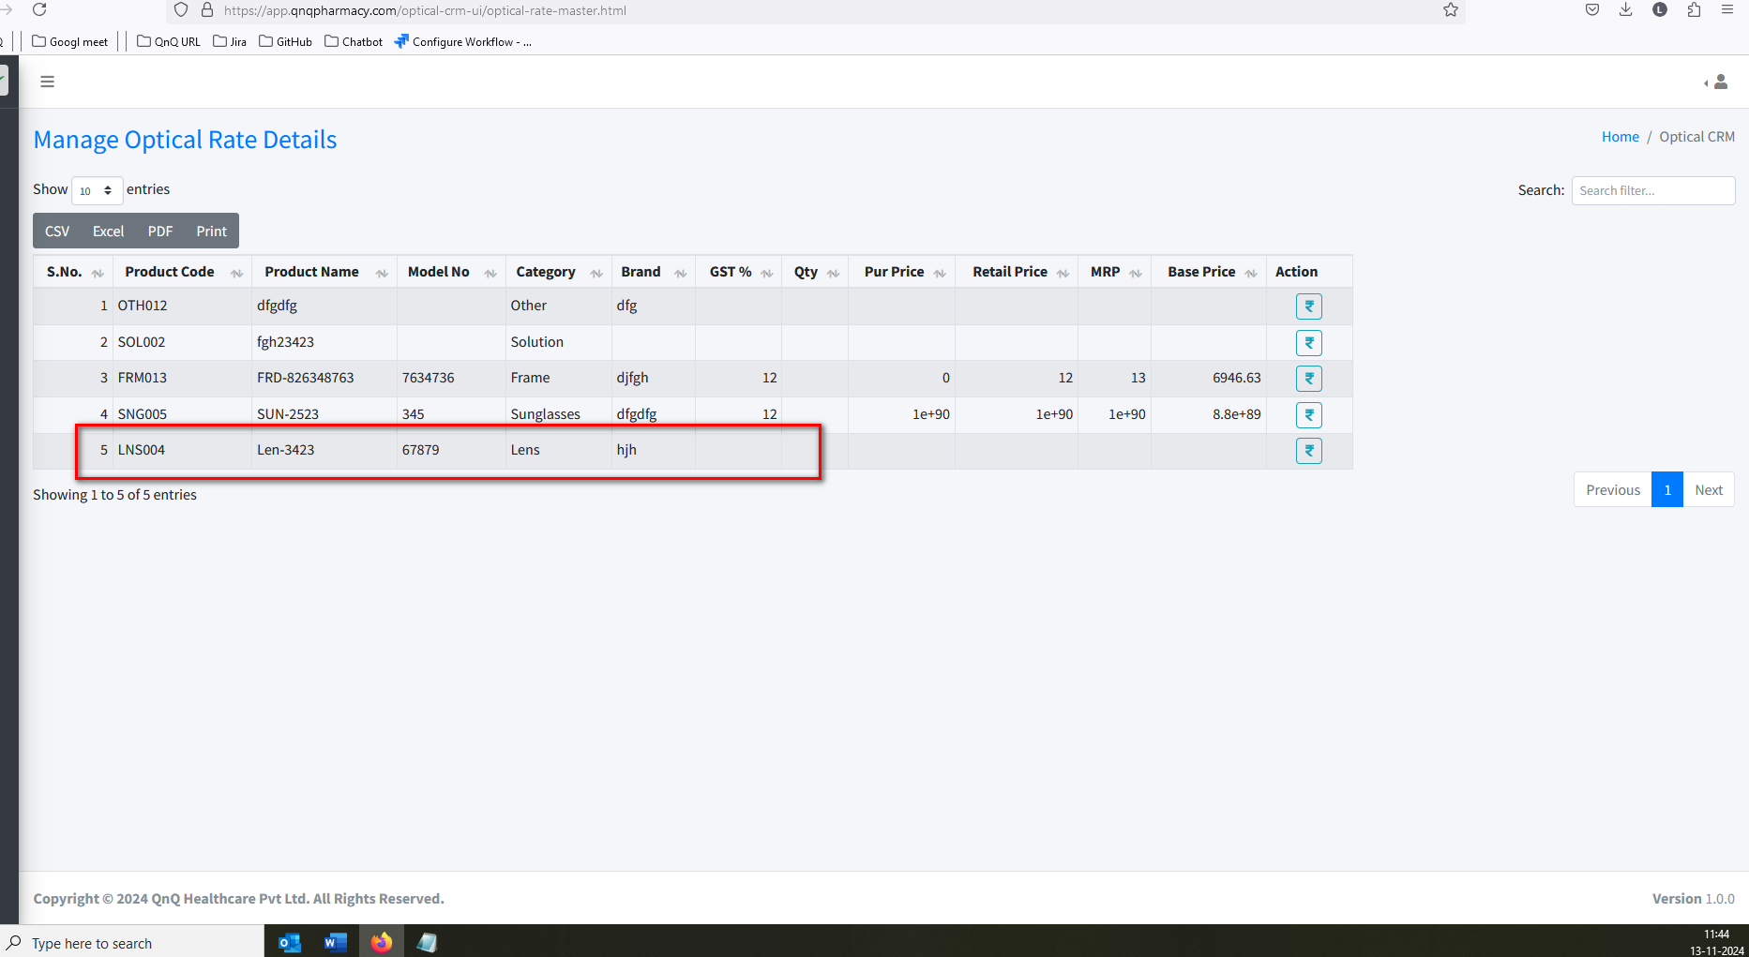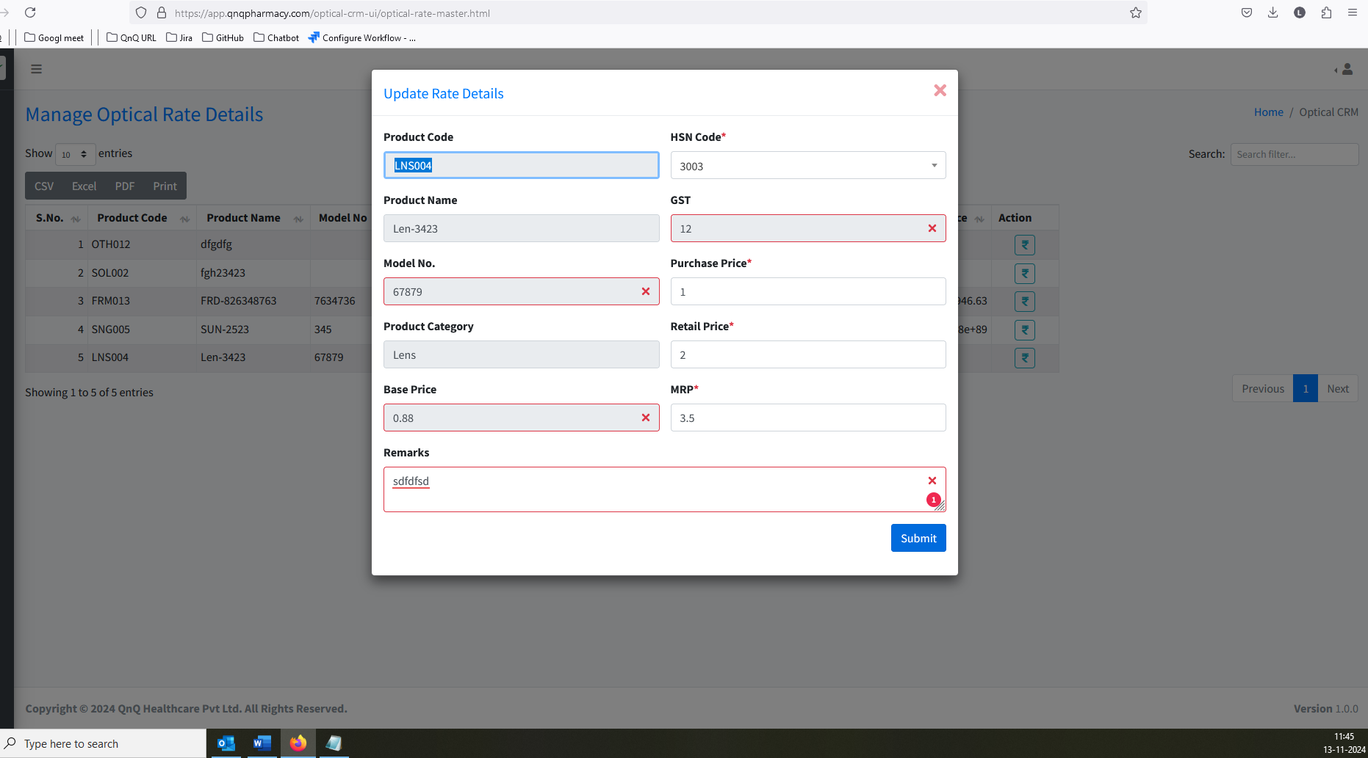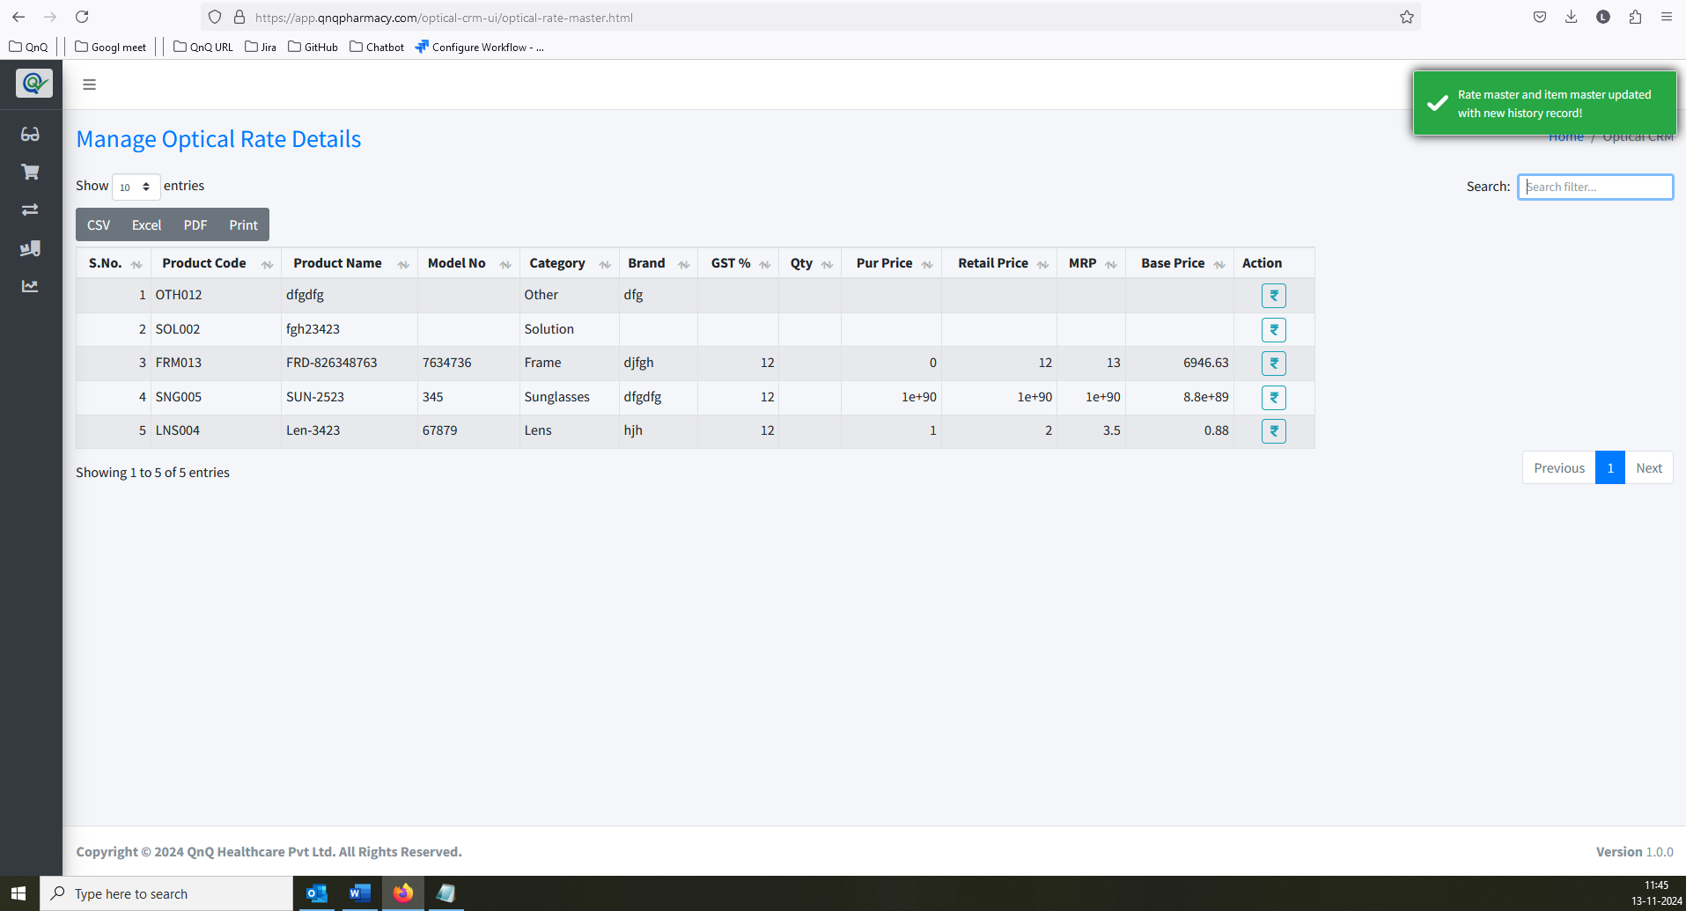//
34. Button name not display as Update in edit mode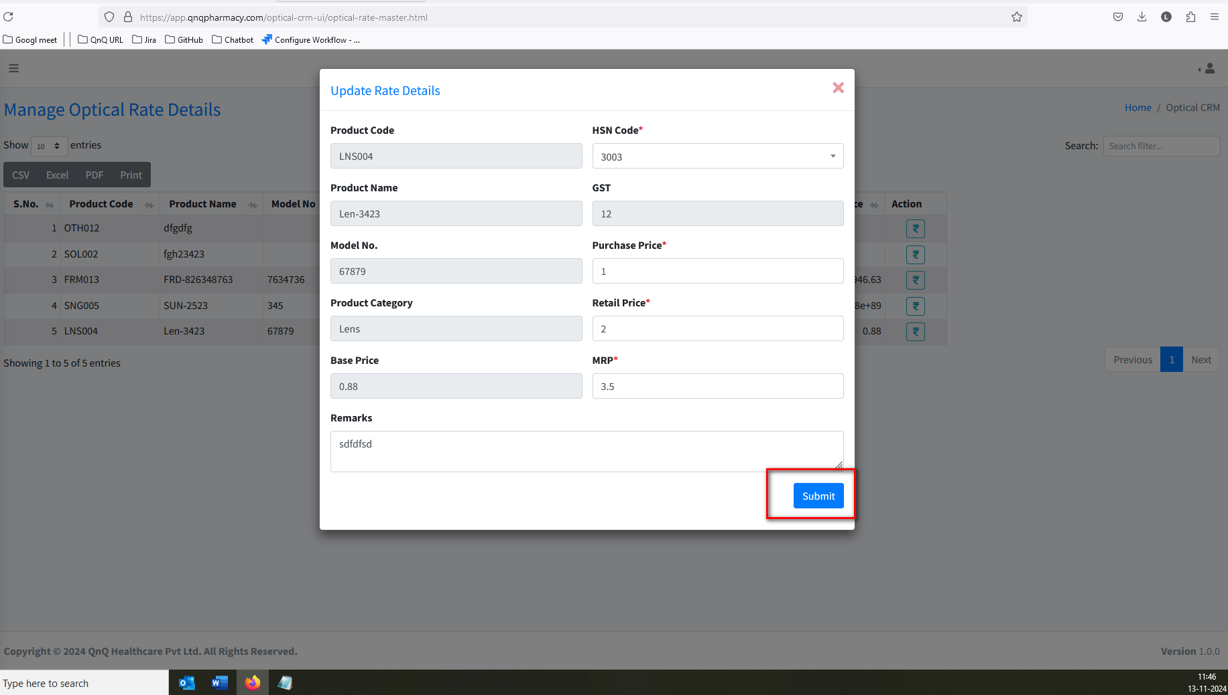//
35. Edit or New batch mode not display in Pop up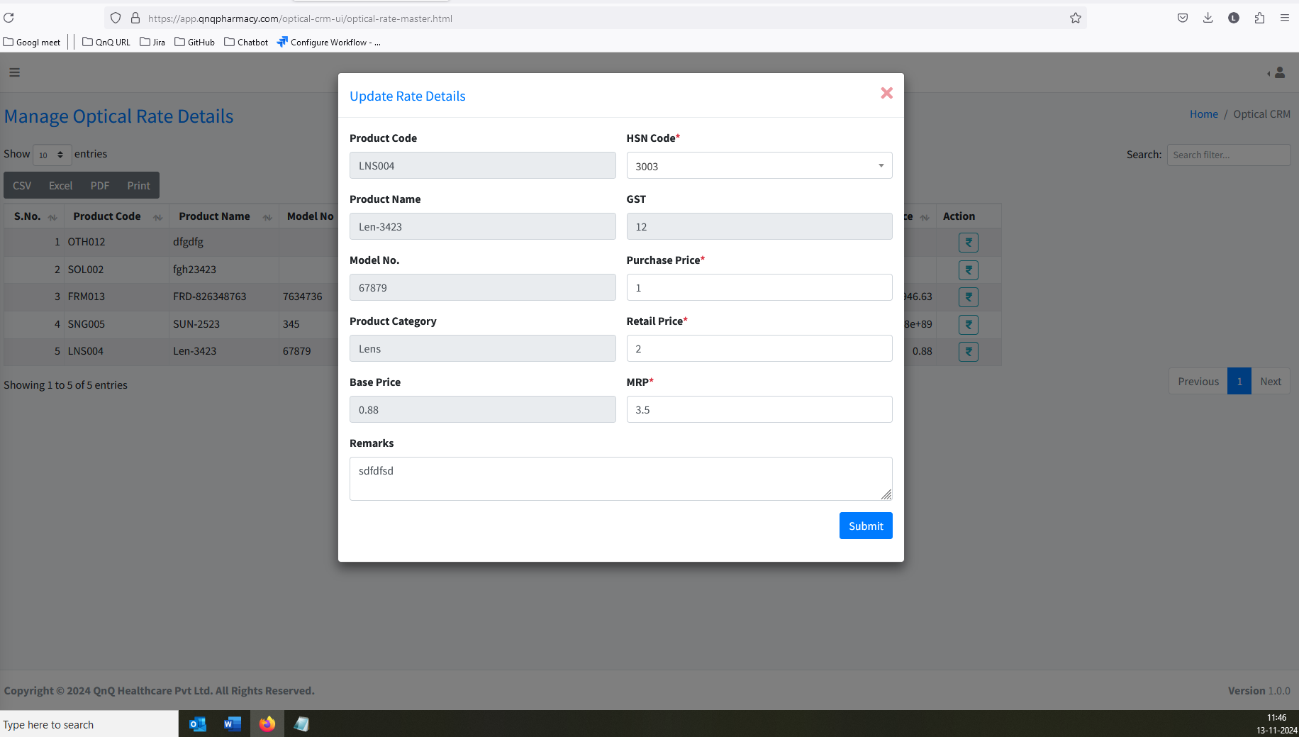//
36. Unwanted content display in all dropdown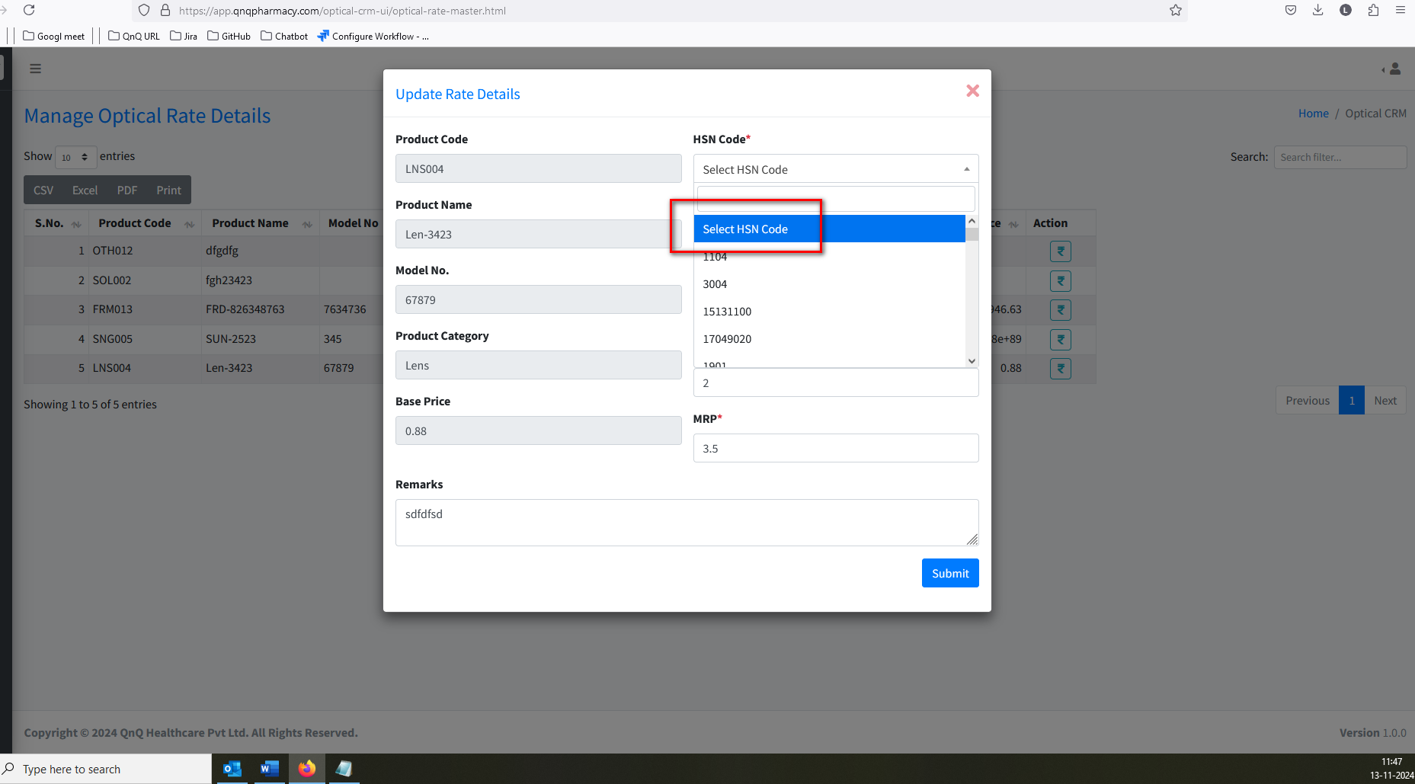//
37. Unwanted Print button display in list grid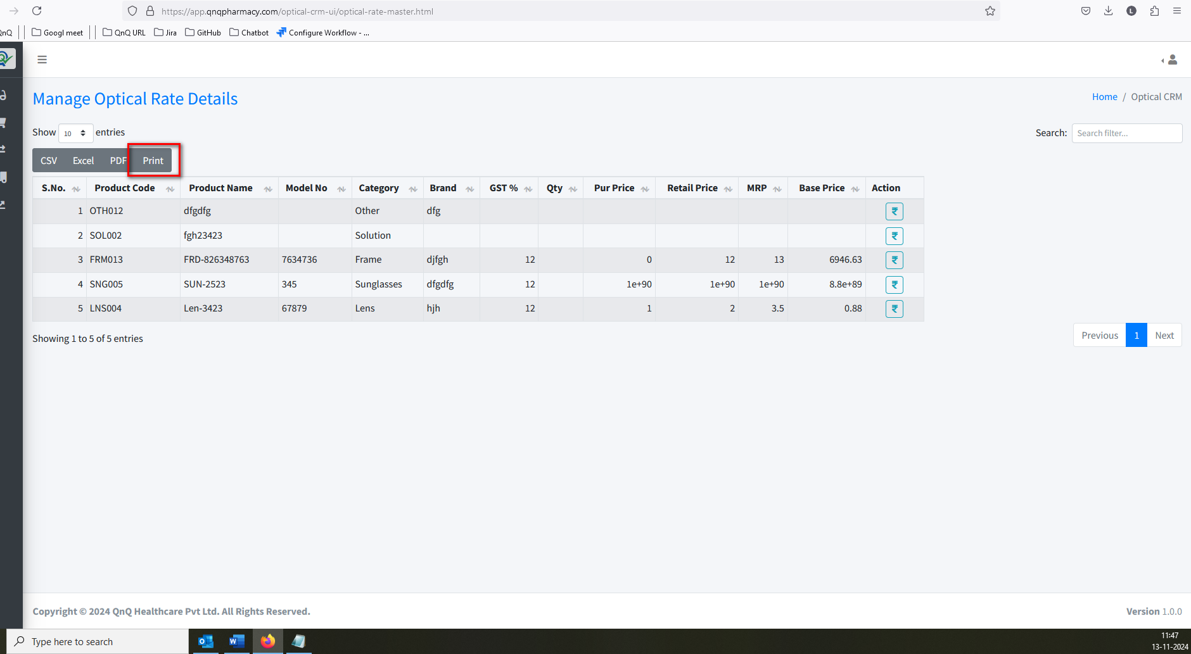//
38. Mismatch File name display in the download file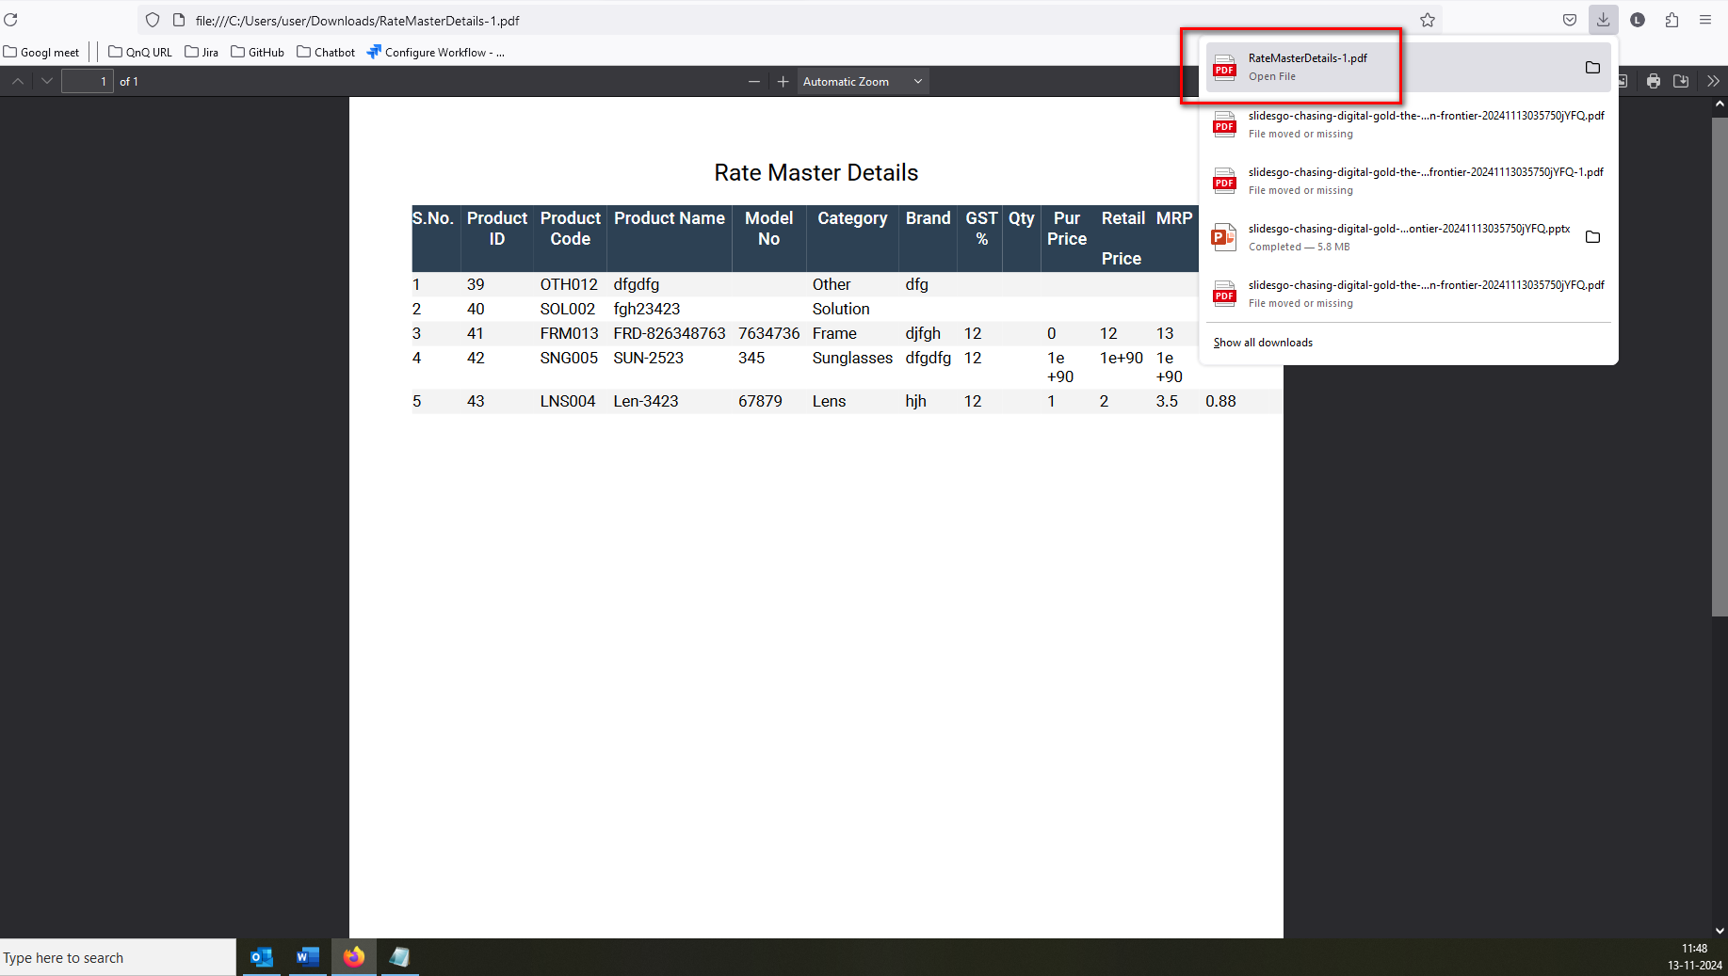//
39. The data is not displaying correctly; some of it is getting lost 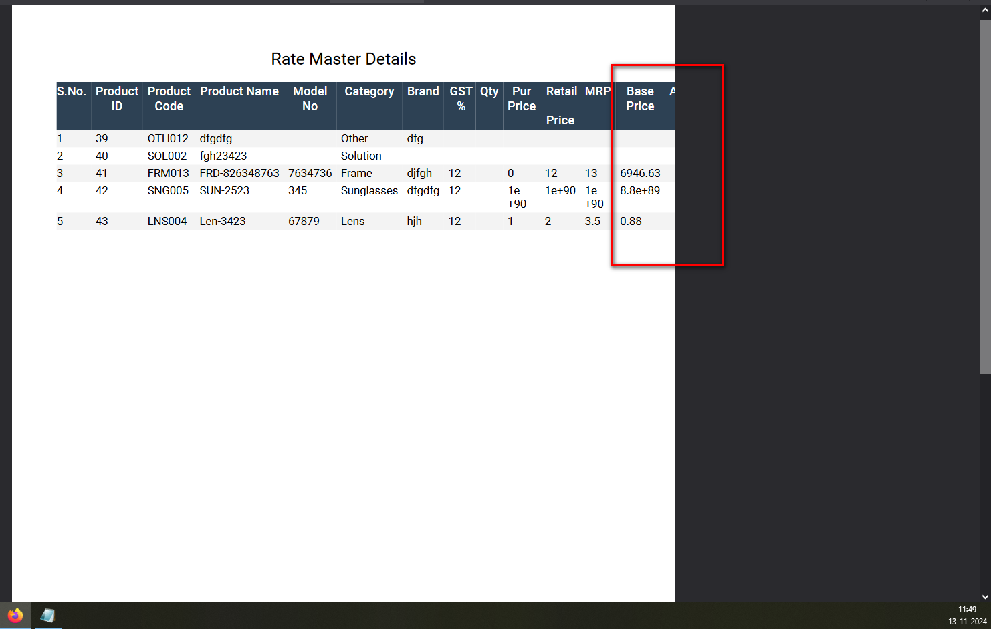//
40. Unwanted error message display while open the CSV file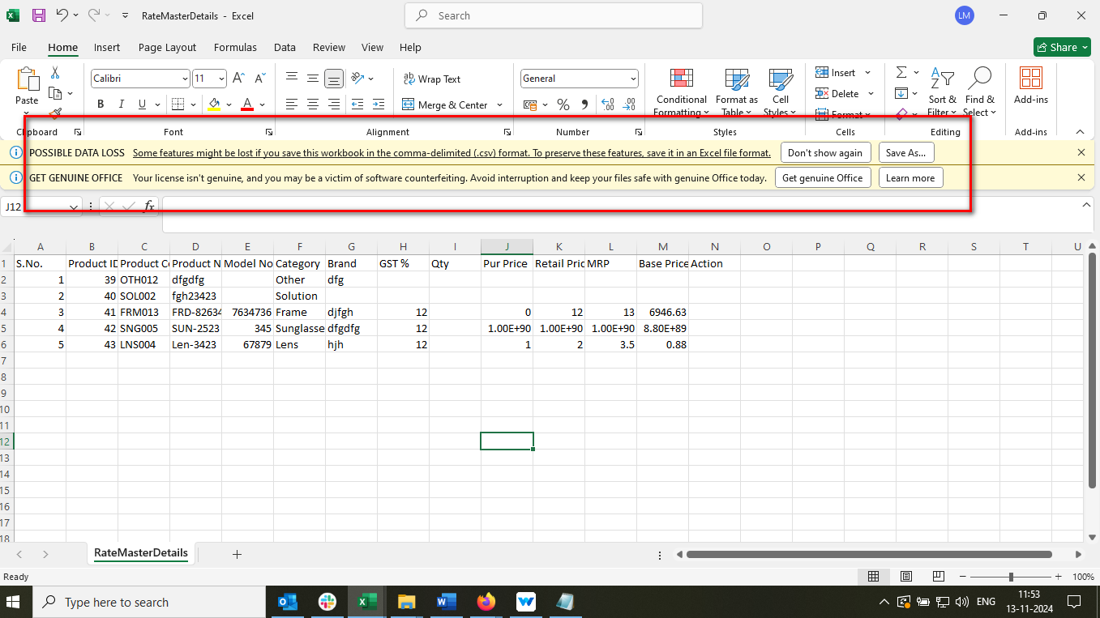//
41. Unwanted column display in download file in file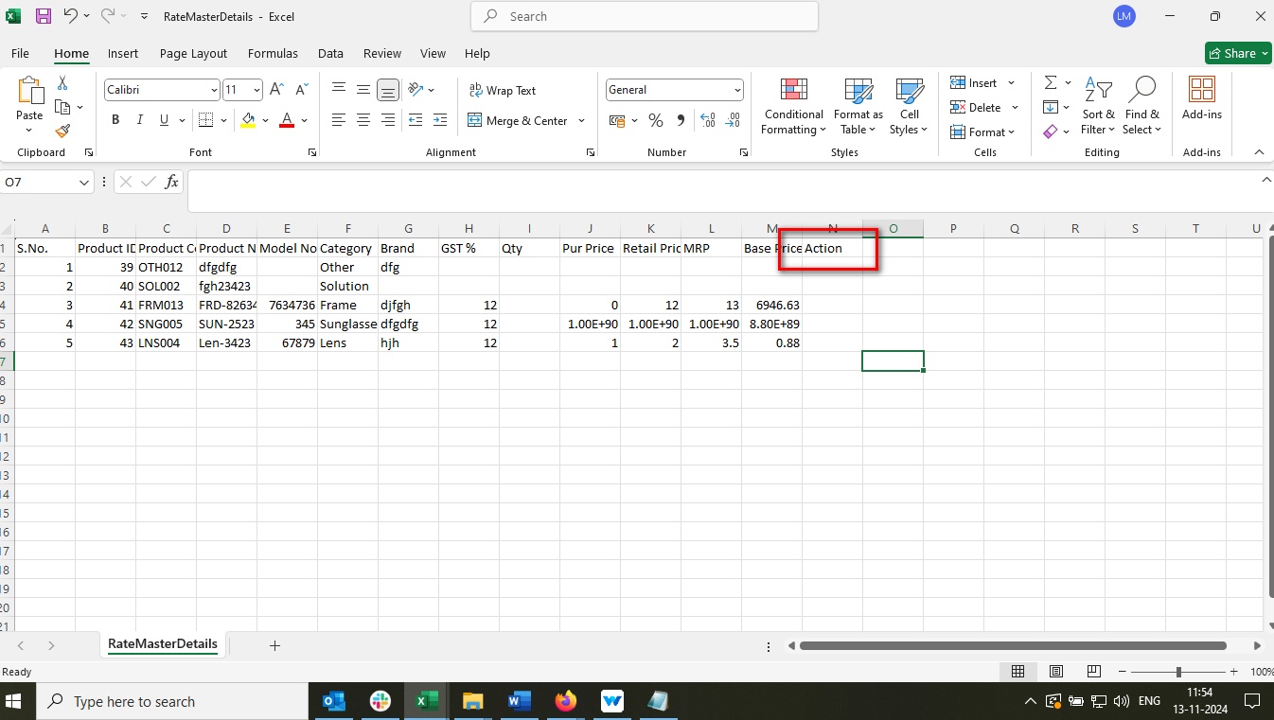 //
42. The column header does not appear like the ad header column in CSV file 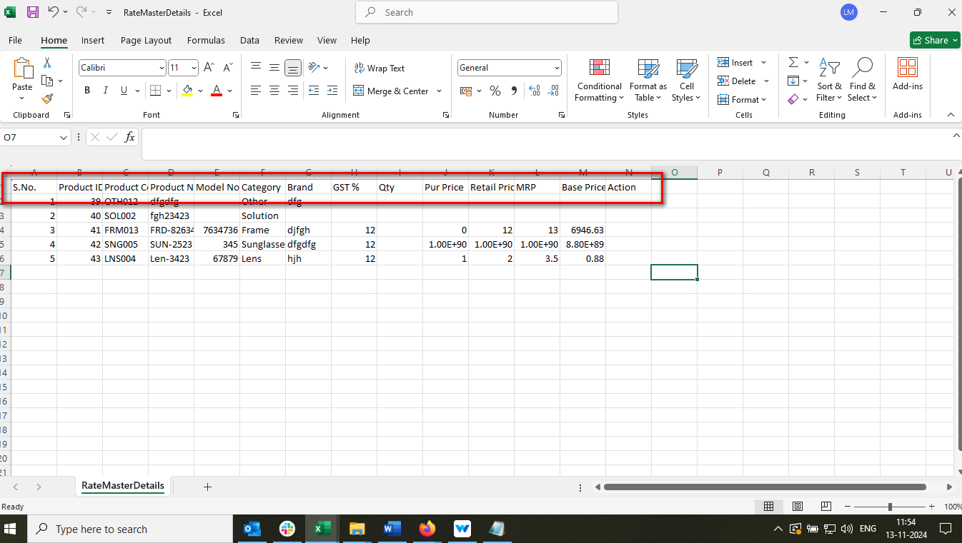//
43. Mismatch sheet name appears in CSV file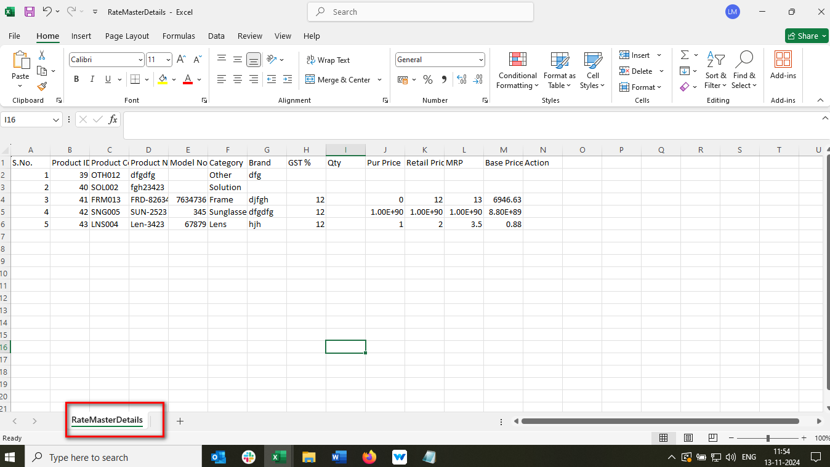//
44. Document Title not display in CSV file 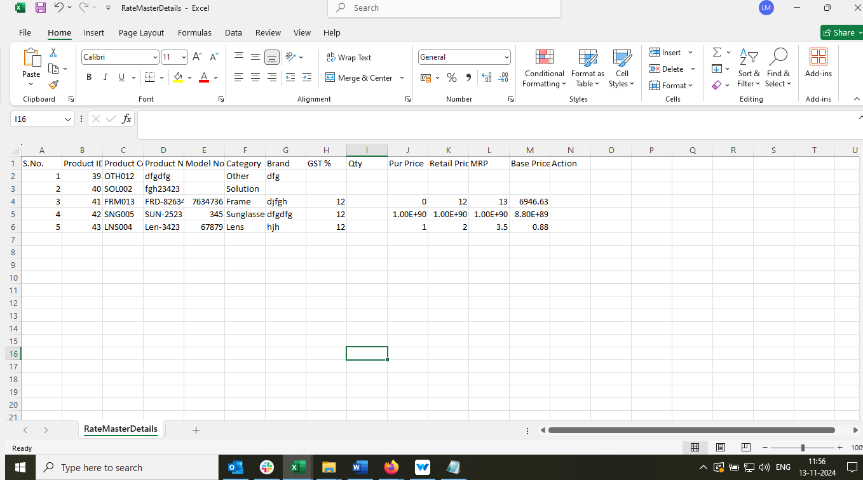//
45. Sheet name not display in excel file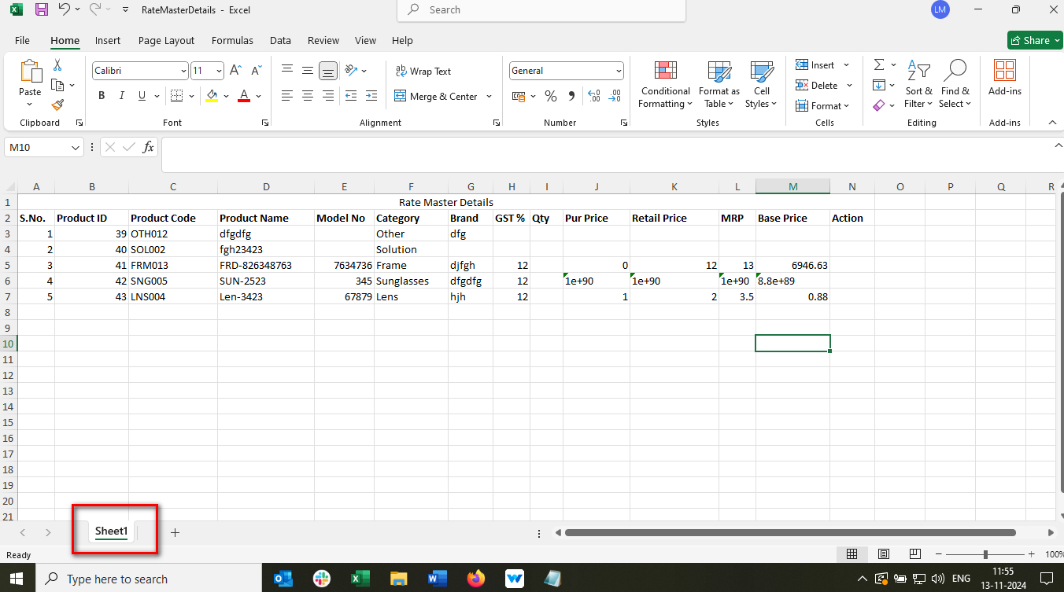 //
46. //
47. //